
CHECKLIST FOR ACCESSIBILITY AUDIT

Produced by :National Federation of Disabled- Nepal (NFDN)

Partnership : CBM

Collaboration : Kathmandu Metropolitan City (KMC)

Technical Cooperation : Square Unit Pvt. Ltd.


“Making physical infrastructures accessible for all”

Preface

Barrier free environment is inevitable to all for independence, convenience and safety. It must be accessible to fulfill needs of those people equally including persons with various types of disabilities. Having this matter into the high consideration, this checklist is developed in assessing the various infrastructures and other services. The checklist has been prepared through the several formal/informal consultation meetings with various stakeholders such as KMC, DPOs alliance, resource pool (a group of technical persons), CBM, NCO and others. The checklist can widely be used by different stakeholders and individuals in their own.

This tools and methodology has been designed to conduct access audit of public infrastructures. This was applied first time to audit the public infrastructures within Kathmandu valley covering representative samples from different sectors such as governmental buildings, health posts /hospitals, schools/colleges, roads/sidewalks, amusement parks, supermarket/Malls, hotels, restaurants and so on.

Our special thanks goes to KMC, CBM NCO, DPOs alliance and members of resource pool who persistently contributed to the development process of the checklist time and again. We are indebted to all members of Square Unit team who tirelessly worked on the same document and brought into the present form. Our debt is beyond the reckoning to Mr. Benzamin Drad, accessibility adviser of CBM International whose valuable comments/inputs made this document comprehensive and more effective. Finally, we are equally thankful to NFDN team and other all stakeholders whose persistent supports have been of inestimable values in developing this document.

National Federation of the Disabled Nepal

2

Introduction

The access audit refers to the assessment process of the

physical accessibility en-route to the building/structure,

physical accessibility of the building/structure and

accessibility of the public service provided within that

building/structure. The purpose of an Accessibility Audit

is to establish how well a particular environment

performs in terms of access and ease of use by a wide

range of potential users, including people with

disabilities and others and also to recommend

improvements, where necessary.

This Accessibility audit checklist has been designed to

be used by access auditors undertaking such access

audit of public infrastructures and other services.

However, the checklist may be used as a basic tool and

may be further developed and innovated by the auditor

depending on the situations and types of building or

service to be audited. The purpose of this tool is to get

uniformity and at least minimum standards in the

recommendations provided in accessibility audit reports

that will be produced.

This tool is based upon the Universal Design Principles

and guidelines stated in (Accessible Physical Infra-

structures and Communication Services Directive for

persons with disabilities, 2069 BS (2012 AD) approved

by the council of ministers in Nepal. Building upon the

manual, we have also incorporated various international

standards applied by developed countries.

3

What is in the checklist?

The checklist for physical accessibility has been written in a sequential

format addressing the priorities that the auditor may prefer to follow.

The checklist goes beyond the physical accessibility and address issues

of making the service provided in the building accessible.

The checklist is divided into four chapters, which is based upon

‘Accessible Physical Structure and Communication Service Directive for

People with disabilities, 2013 AD’, approved by Government of Nepal

(Council of ministries)

- Chapter 1:

The first chapter includes questionnaire on the common building

elements.

- Chapter 2:

The second chapter focuses on the accessibility of the en-route to the public buildings. The questionnaire is designed to answer the relative difficulty of the person with disabilities in reaching the infrastructure, parking, paths surrounding the infrastructure, curb ramps and main entrance.

- Chapter 3:

The chapter focuses on the accessibility of the public services

provided within the building. The questionnaire addresses

accessibility in the passage, lobby, horizontal and vertical circulation,

doors inside the building, equipment control & uses, services,

sanitary facilities and security services.

- Chapter 4:

The final chapter includes questionnaire on accessibility of the

person with disabilities in getting relevant information and

communication services within the building.

4

How to use this Checklist?

- Before the survey, the head surveyor will instruct the survey team on the etiquettes of the survey. Carefully listen to the directions on the do’s and don’t’s of the project.

- Be systematic:

The survey group may consist of 4 or more people including surveyors and user group. Each one should be assigned to perform specific job like taking measurements, filling out the checklist and taking photos. Comments from the user group should be incorporated into the checklist.

- Print copies of checklist:

Work out the amount of copies of the checklist required to audit each section of the building.

  - Develop a plan

  - Make changes

- Collect the necessary tools:

  - Checklist

  - Laser Tape Measure

  - Electronic level

  - Door pressure gauge

  - Camera

  - Clipboard folder

  - Bag

5

How to use this Checklist?

- Carrying out the survey

  - Start the survey assessing whether the elements of Travel Chain like pedestrian access, vehicles, and transfer points are accessible. Then, include correct number of accessible parking spaces, entrances and whether proper signs in place to redirect people from inaccessible entrances to accessible entrances in the next step. Finally, go inside and survey the internal sections.

  - Carefully document the details of the survey in the checklist.

  - Take Good Measurements

  - Re-evaluate

  - After the survey

  - List the results and recommendations

  - Prepare a draft report

  - Share the key findings

  - Develop a plan

  - Make changes

6

CHECKLIST
FOR ACCESSIBILITY OF PUBLIC INFRASTRUCTURE

Note

The following questionnaire is the accessibility audit of public infrastructure in Kathmandu Valley which can be adapted to suit the accessibility of various spaces and buildings of different sectors.

Details of the Infrastructure

Code :

District:

Address:

Sectors : | Health | Education
Service Establishments | Health | Education
Corporate | Food & Accommodation | Commercial
Recreation & Entertainment | Transportation | Public Toilet
Community & Heritage | Sports & Fitness | Others

Opening times of the Infrastructure:

Details of the person who filled in the

questionnaire

L ast name/first name:

Profession/activity:

Address:

Organisation (if a member of an organization):

Chapter 1: Common Building Elements

Signage

Types of Signage
    - Directional

    - Information

    - Identification

    - Instructive

    - Health & Safety

- Signs should be provided at all appropriate locations including approach to building / facility / service, entrance / exit, main lobby or reception, public facilities such as library, toilets etc., department and offices, fire exits and parking and garages.

- A good signage scheme should cover all public buildings, spaces, and facilities including transportation infrastructure and should include locations such as:

o Approach to building / facility o Entrance / exit

o Main lobby or reception

o Public facilities such as library, toilets etc. o Parking and garages

o Departments and offices o Fire exits

- Universal signage has following components: (Color contrasts signs, Character, content and layout, Pictograms and accessibility symbols, Positioning, Viewing distance, lighting)

- Braille and tactile signage should be placed at a height between 3 feet (900mm) to 5 feet (1500mm). Ideal location at 3 feet 6 inches (1050mm) above the finished level.

- Duplicating detailed signs and instructions, specially safety notices, should be located at high and low levels , i.e. at 5 feet

– 4 inches (1600mm) to 5 feet – 8 inches (1700mm) and at 3 feet - 4 inches (1000mm) to 3 feet - 8 inches (1100mm) to allow convenient close viewing by wheelchair users.

8

Chapter 1: Common Building Elements

Color Contrast

- Text should contrast with sign background
- Sign should contrast with environment

- Light levels (measured in lux)

- 70% contrast between wall and sign panels

- Avoid shades of colors

- Avoid using same color as safety signs

- Maximum 5 colors

- Non reflective surface

- Schedule for color contrast with sign background is given in following table:

Background | Sign Board | Legend
Red Brick or Dark Stone | White | Black, dark green or dark blue
Light brick or light stone | Black/Dark | White or Yellow
Whitewashed walls | Black/Dark | White/Yellow
Green Vegetation | White | Black, dark green or dark blue
Back-lit sign | Black | White or Yellow

9

Chapter 2: External Services & Benefits

1.Reaching the infrastructure

 |  | Y/N | Standard | Reference | Recommendation
1.1 | Is the infrastructure accessible by public | □Yes
 | transportation? | □No
1.2 | Is there any kind of barriers or hurdles in | □Yes
 | sidewalk for movement? | □No
1.3 | Is tactile blocks laid in Sidewalk and road | □Yes
 | crossing place? | □No
1.4 | Does the destination has visible and | □Yes
 | legible sign post? | □No

10

Chapter 2: External Services & Benefits

2. Parking

 |  | Y/N |  | Standard |  |  |  |  | Reference | Recommendation
2.1 | If parking is provided for the public, are an | □Yes |  | Total Space |  | Accessible
2.1 | If parking is provided for the public, are an | □Yes |  |  |  | Space
 | adequate number of accessible spaces | □No |  |  |  | Space
 | adequate number of accessible spaces | □No |  | 1 - 25 |  |  | 1
 | provided? | □No |  | 1 - 25 |  |  | 1
 |  | Total: |  | 26 - 50 |  |  | 2
 |  | Accessi | 51 - 75 |  |  |  | 3
 |  | Accessi | 76 - 100 |  |  |  | 4
 |  | ble: |  |  |  |  | 4
2.2 | Is the scooter (with supportive wheels) | □Yes
 | accessible space: | □No
 | At least 4 feet wide and 5 feet long, with | □No
 | at least 3 feet gap between two parked
 | scooter?
2.3 | Of the accessible spaces, is at least one a | □Yes |  | *For every 6 or fraction of
 | van accessible space?* | □No |  | 6 parking spaces required
 |  | □No |  | by the table above, at least
 |  |  |  | 1 should be a vehicle
 |  |  |  | accessible space.
2.4 | Is the van accessible space: | □Yes
 | At least 11 feet wide with an access aisle | □No
 | at least 5 feet wide? | _____
 | Or | □Yes
 | At least 8 feet wide with an access aisle | □No
 |  | _______
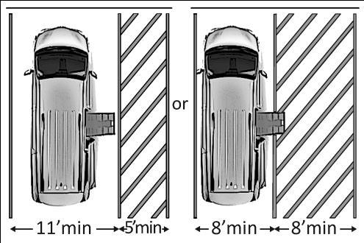

11

Chapter 2: External Services & Benefits

2. Parking

 |  | Y/N | Standard | Reference | Recommendation
2.5 | Are accessible spaces at least 8 feet wide | □Yes
 | with an access aisle at least 5 feet wide? | □No
 | Note: Two spaces may share an access | ______
 | aisle. Check state/local requirements;
 | some specify that each space have its own
 | aisle.
2.6 | Do the access aisles adjoin an accessible | □Yes
 | route? | □No
2.7 | Are accessible spaces identified with a sign | □Yes
 | that includes the International Symbol of | □No
 | Accessibility?
 | Is the bottom of the sign at least 60 inches | □Yes
 | above the ground? | □No
 | Note: The International Symbol of
 | Accessibility is not required on the ground.
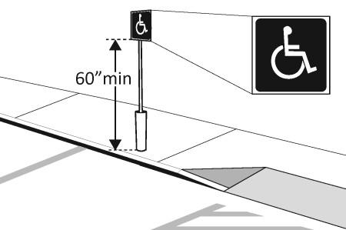
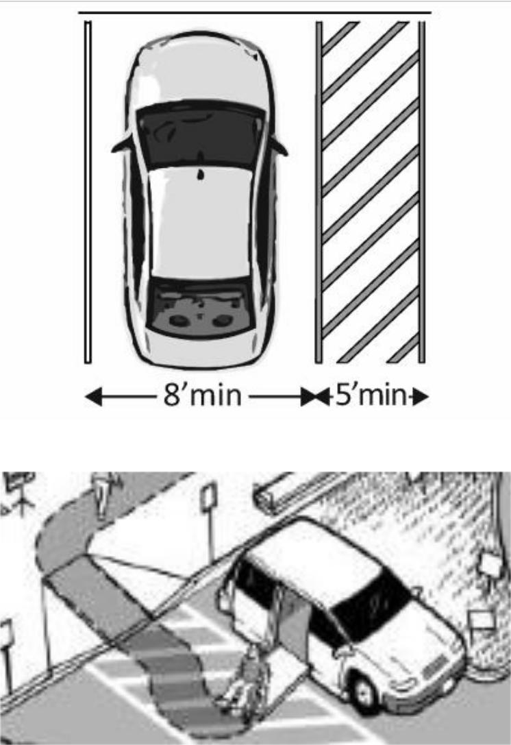

12

Chapter 2: External Services & Benefits

3. Paths around Infrastructure
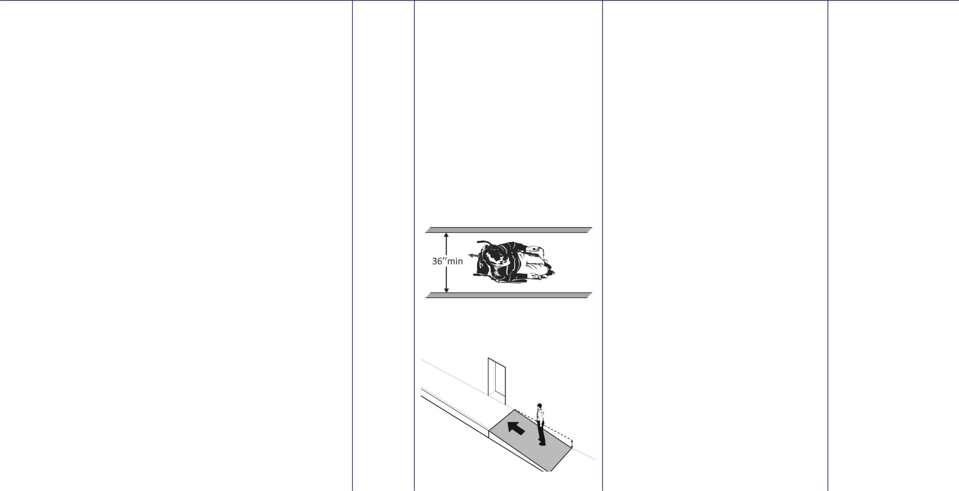

Y/N | Standard | Reference | Recommendation

3.1 | Is the route stable, firm and slip-resistant? | □Yes
 |  | □No
3.2 | Is the route at least 36 inches wide? | □Yes
 |  | □No
 |  | ______
3.3 | Is the running slope no steeper than 1:20, | □Yes
 | i.e. for every inch of height change there | □No
 | are at least 20 inches of route run?
 | Note: If the running slope is steeper than
 | 1:20, treat as a ramp and add features
 | such as edge protection and handrails

13

Chapter 2: External Services & Benefits

4. Curb Ramps

 |  | Y/N | Standard | Reference | Recommendation
4.1 | If the accessible route crosses a curb, is | □Yes
 | there a curb ramp? | □No
4.2 | Is the running slope of the curb ramp no | □Yes
 | steeper than 1:12, i.e. for every inch of | □No
 | height change there are at least 12 inches | □No
 | of curb ramp run? | ______
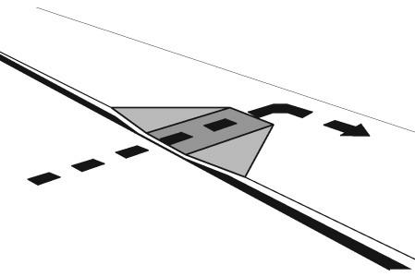
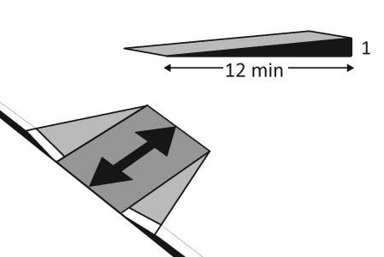

14

Chapter 2: External Services & Benefits

5. Stairs

 |  | Y/N | Standard | Reference | Recommendation
5.1 | Is the tread not less than 11inches wide? | □Yes
 |  | □No
 | Is the riser not more than 6.5inches wide? | □Yes
 |  | □No
5.2 | What is the width of the staircase?
 |  | ____
5.3 | Stairs have continuous rails on both sides? | □Yes
 |  | □No
 | Do they extend 12 inches beyond the top | □Yes
 | and bottom of any flight? | □No
5.4 | Is the height of the rail between 34inches | □Yes
 | and 38inches? | □No

15

Chapter 2: External Services & Benefits

5. Stairs

 |  | Y/N | Standard | Reference | Recommendation
5.5 | If the handrail gripping surface is circular, | □Yes
 | is it no less than 1 ¼ inches and no greater | □No
 | than 2 inches in diameter?
5.6 | If the handrail gripping surface is non- | □Yes
 | circular: | □No
 | Is the perimeter no less than 4 inches and
 | no greater than 6¼ inches?
5.7 | If there are landings, are they large | □Yes
 | enough to permit passing and turning | □No
 | manoeuvres, and are they provided in any | □No
 | long flight?
5.8 | Is the surface of the stairs slip-resistant? | □Yes
 |  | □No
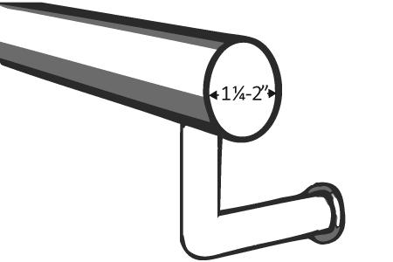
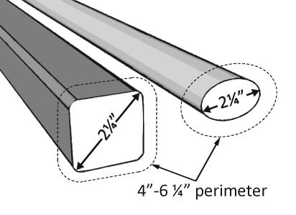

16

Chapter 2: External Services & Benefits

6. Ramps

 |  | Y/N | Standard | Reference | Recommendation
6.1 | If there is a ramp is it at least 36 inches | □Yes
 | wide? | □No
 | Note: If there are handrails, measure | ______
 | between the handrails.
6.2 | Is the surface stable, firm and slip | □Yes
 | resistant? | □No
6.3 | For each section of the ramp, is the | □Yes
 | running slope no greater than 1:12, i.e. for | □No
 | every inch of height change there are at
 | least 12 inches of ramp run?
 | Note: Rises no greater than 3 inches with a
 | slope no steeper than 1:8 and rises no
 | greater than 6 inches with a slope no
 | steeper than 1:10 are permitted when
 | such slopes are necessary due to space
 | limitations.
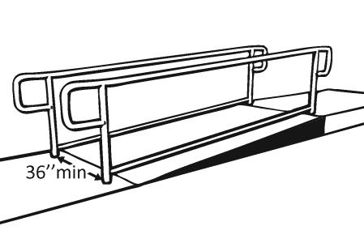
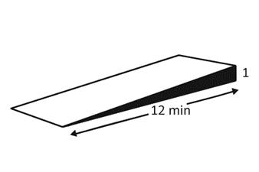

17

Chapter 2: External Services & Benefits

6. Ramps

 |  | Y/N | Standard | Reference | Recommendation
6.4 | Is there a level landing that is at least 60 | □Yes
 | inches long and at least as wide as the | □No
 | ramp: | □No
 | At the top of the ramp? | □Yes
 | At the bottom of the ramp? | □No
6.5 | Is there a level landing where the ramp | □Yes
 | changes direction that is at least 60 x 60 | □No
 | inches?
 |  | ______
6.6 | f the ramp has a rise higher than 6 inches, | □Yes
 | are there handrails on both sides? | □No
 | Note: Curb ramps are not required to have | ______
 | handrails.
6.7 | Is the top of the handrail gripping surface | □Yes
 | no less than 34 inches and no greater than | □No
 | 38 inches above the ramp surface?
 |  | ______
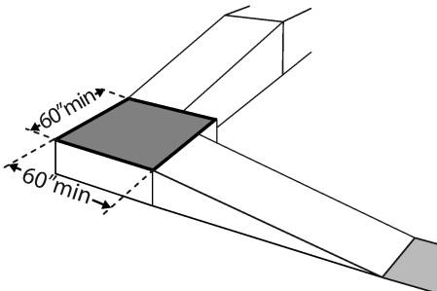
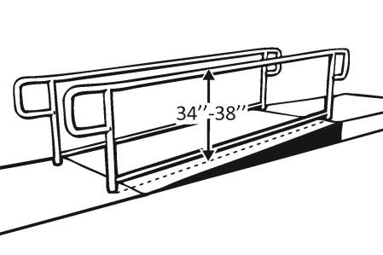
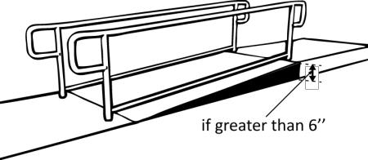
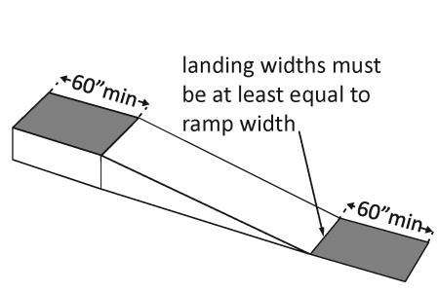

18

Chapter 2: External Services & Benefits

6. Ramps

 |  | Y/N | Standard | Reference | Recommendation
6.8 | If the handrail gripping surface is circular, | □Yes
 | is it no less than 1 ¼ inches and no greater | □No
 | than 2 inches in diameter?
6.9 | If the handrail gripping surface is non- | □Yes
 | circular: | □No
 | Is the perimeter no less than 4 inches and
 | no greater than 6¼ inches?

19

Chapter 2: External Services & Benefits

7. Main Entrance

 |  | Y/N | Standard | Reference | Recommendation
7.1 | Is the main entrance accessible? | □Yes
 |  | □No
7.2 | If the main entrance is not accessible, is | □Yes
 | there an alternative accessible entrance? | □No
 | Can the alternative accessible entrance be | □Yes
 | used independently and during the same | □No
 | hours as the main entrance?
7.3 | Do all inaccessible entrances have signs | □Yes
 | indicating the location of the nearest | □No
 | accessible entrance? | □No
7.4 | If not all entrances are accessible, is there | □Yes
 | a sign at the accessible entrance with the | □No
 | International Symbol of Accessibility?
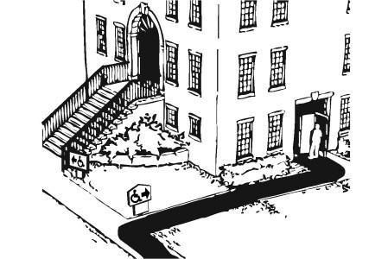
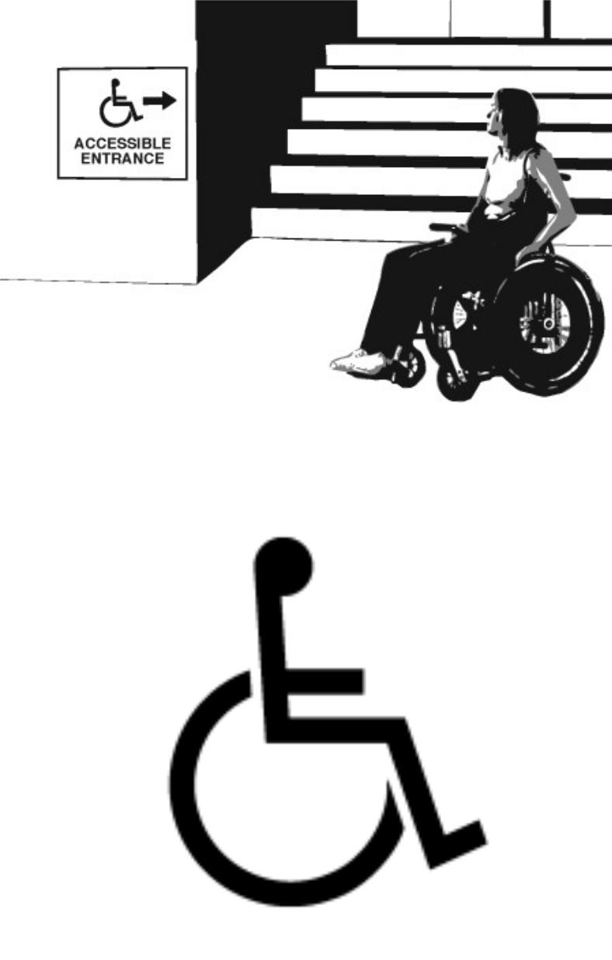

20

Chapter 3: Internal Service & Facilities

8. Door

 |  | Y/N | Standard | Reference | Recommendation
8.1 | Is the clear opening width of the | □Yes
 | accessible entrance door at least 32 | □No
 | inches, between the face of the door and | □No
 | the stop, when the door is open 90 | ______
 | degrees?
8.2 | If there is a front approach to the pull side | □Yes
 | of the door, is there at least 18 inches of | □No
 | maneuvering clearance beyond the latch | □No
 | side plus at least 60 inches clear depth? | _______
 | On both sides of the door, is the ground or | □Yes
 | On both sides of the door, is the ground or | □No
 | floor surface of the maneuvering
 | clearance level (no steeper than 1:48)? | ______
8.3 | If the threshold is vertical is it no more | □Yes
 | than ¼ inch high? | □No
 |  | ______
8.4 | Are the operable parts of the door | □Yes
 | hardware no less than 34 inches and no | □No
 | greater than 48 inches above the floor or | □No
 | ground surface?
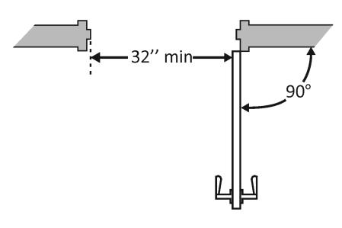
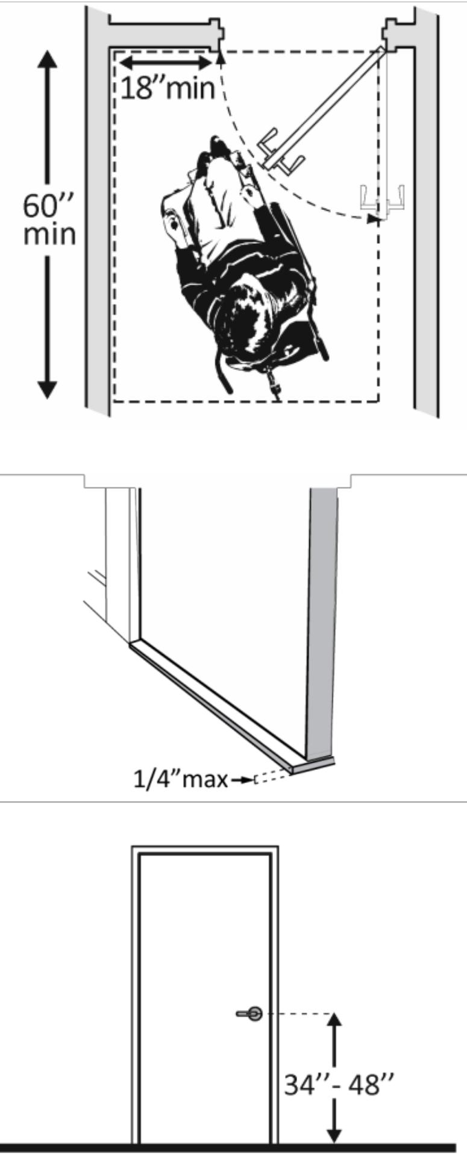

21

Chapter 3: Internal Service & Facilities

8. Door

 |  | Y/N | Standard | Reference | Recommendation
8.5 | Is the door equipped with hardware that | □Yes
 | is operable with one hand and does not | □No
 | require tight grasping, pinching or
 | twisting of the wrist? | □Yes
 | Door handle? | □No
 | Lock (if provided)? | □Yes
 |  | □No
8.6 | Can the door be opened easily (5 pounds | □Yes
 | maximum force)? | □No
 | Note: You can use a pressure gauge or fish | Measu
 | scale to measure force. If you do not have | rement
 | one you will need to judge whether the
 | door is easy to open.
8.7 | Are floor surfaces stable, firm and slip | □Yes
 | resistant? | □No
8.8 | If provided at the building entrance, are | □Yes
 | carpets or mats no higher than ½ inch | □No
 | thick? | □No
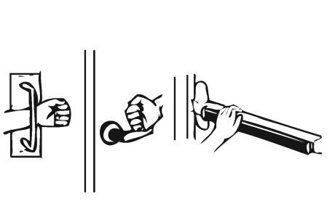
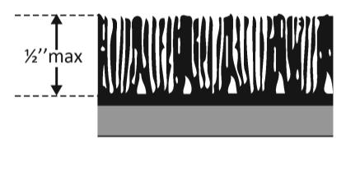
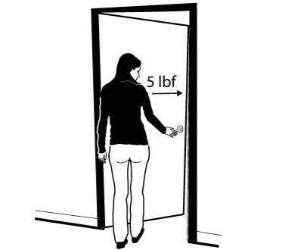

22

Chapter 3: Internal Service & Facilities

9. Inside the Building

 |  |  |  | Y/N | Standard | Reference | Recommendation
 | Interior Accessible Route
9.1 | Are all public spaces on at least one |  |  | □Yes
 | accessible route? |  |  | □No
9.2 | Is the route stable, firm and slip-resistant? |  |  | □Yes
 |  |  |  | □No
9.3 | Is the route at least 36 inches wide? |  |  | □Yes
 | Note: The accessible route can narrow to |  |  | □No
 | 32 inches min. for a max. of 24 inches. |  |  | ______
 | These narrower portions of the route
 | must be at least 48 inches from each
 | other.
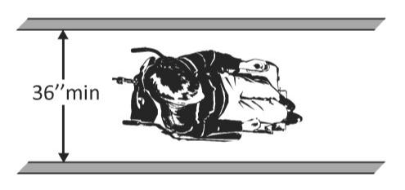
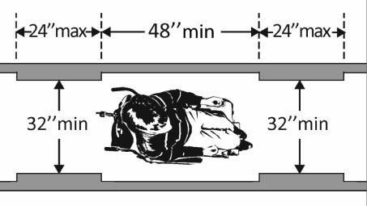

23

Chapter 3: Internal Service & Facilities

9. Inside the Building
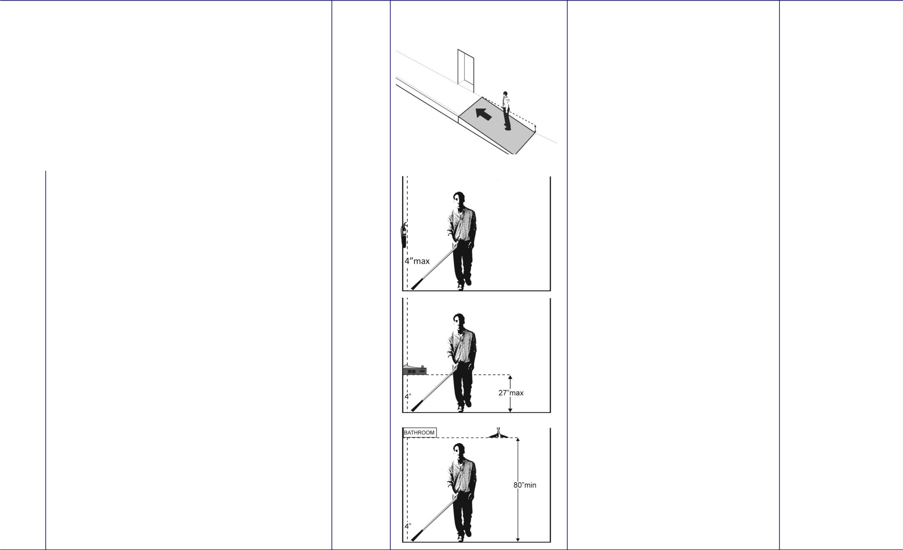

Y/N | Standard | Reference | Recommendation

9.4 | Is the running slope no steeper than 1:20, | □Yes
 | i.e. for every inch of height change there | □No
 | are at least 20 inches of route run?
 | Note: If the running slope is steeper than | ______
 | 1:20, treat as a ramp and add features
 | such as edge protection and handrails
9.5 | Do all objects on circulation paths through | □Yes
 | public areas, e.g. fire extinguishers, | □No
 | drinking fountains, signs, etc., protrude no | □No
 | more than 4 inches into the path? | _____

Or | □Yes
If an object protrudes more than 4 inches, | □Yes
is the bottom leading edge at 27 inches or | □No
lower above the floor? | _____

Or | □Yes
Or | □No
Is the bottom leading edge at 80 inches or | □No
higher above the floor? | _____

24

Chapter 3: Internal Service & Facilities

9. Inside the Building

 |  |  | Y/N | Standard | Reference | Recommendation
Staircase
9.6 Is the tread not less than 11inches wide? |  |  | □Yes
 |  |  | □No


Is the riser not more than 6.5inches wide? □Yes

□No

9.7 What is the width of the staircase?

____

9.8 Stairs have continuous rails on both sides? _{□Yes}

□No

Do they extend 12 inches beyond the top
and bottom of any flight?

9.9 Is the height of the rail between 34inches | □Yes
and 38inches? | □No

25
Chapter 3: Internal Service & Facilities

9. Inside the Building

 |  | Y/N | Standard | Reference | Recommendation
9.10 | If the handrail gripping surface is circular, | □Yes
 | is it no less than 1 ¼ inches and no greater | □No
 | than 2 inches in diameter?
9.11 | If the handrail gripping surface is non- | □Yes
 | circular: | □No
 | Is the perimeter no less than 4 inches and | □Yes
 | no greater than 6¼ inches? | □No
9.12 | If there are landings, are they large | □Yes
 | enough to permit passing and turning | □No
 | manoeuvres, and are they provided in any | □No
 | long flight?
9.13 | Is the surface of the stairs slip-resistant? | □Yes
 |  | □No

26

Chapter 3: Internal Service & Facilities

9. Inside the Building

 |  |  |  | Y/N | Standard | Reference | Recommendation
 | Ramps
9.14 | If there is a ramp is it at least 36 inches |  |  | □Yes
 | wide? |  |  | □No
 | Note: If there are handrails, measure |  |  | ______
 | between the handrails.
9.15 | Is the surface stable, firm and slip |  |  | □Yes
 | resistant? |  |  | □No
9.16 | For each section of the ramp, is the |  |  | □Yes
 | running slope no greater than 1:12, i.e. for |  |  | □No
 | every inch of height change there are at
 | least 12 inches of ramp run?
 | Note: Rises no greater than 3 inches with a
 | slope no steeper than 1:8 and rises no
 | greater than 6 inches with a slope no
 | steeper than 1:10 are permitted when
 | such slopes are necessary due to space
 | limitations.

27

Chapter 3: Internal Service & Facilities

9. Inside the Building

 |  | Y/N | Standard | Reference | Recommendation
9.17 | Is there a level landing that is at least 60 | □Yes
 | inches long and at least as wide as the | □No
 | ramp: | □No
 | At the top of the ramp? | □Yes
 | At the bottom of the ramp? | □No
9.18 | Is there a level landing where the ramp | □Yes
 | changes direction that is at least 60 x 60 | □No
 | inches?
 |  | ______
9.19 | f the ramp has a rise higher than 6 inches, | □Yes
 | are there handrails on both sides? | □No
 | Note: Curb ramps are not required to have | ______
 | handrails.
9.20 | Is the top of the handrail gripping surface | □Yes
 | no less than 34 inches and no greater than | □No
 | 38 inches above the ramp surface?
 |  | ______

28

Chapter 3: Internal Service & Facilities

9. Inside the Building

 |  | Y/N | Standard | Reference | Recommendation
9.21 | If the handrail gripping surface is circular, | □Yes
 | is it no less than 1 ¼ inches and no greater | □No
 | than 2 inches in diameter?
9.22 | If the handrail gripping surface is non- | □Yes
 | circular: | □No
 | Is the perimeter no less than 4 inches and
 | no greater than 6¼ inches?

29

Chapter 3: Internal Service & Facilities

9. Inside the Building

 |  |  | Y/N |  | Standard | Reference | Recommendation
 | Elevators – Full Size & LULA (limited use, limited application)
9.23 | Are there elevators or platform lifts to all |  | □Yes
 | public stories? |  | □No
9.24 | If there is a elevator, does the sliding door |  | □Yes
 | reopen automatically when obstructed by |  | □No
 | an object or person?*
9.25 |  | If there is a full size or LULA elevator, | □Yes
 |  | are there horizontal grab bars? | □No
 |  | At the maximum height of 3 feet | □Yes
 |  |  | □No
9.26 | If there is a full size elevator: |  | □Yes
 | Is the interior at least 54 inches deep by at |  | □No
 | least 36 inches wide with at least 16 sq. ft. |  | ______
 | of clear floor area? |  | □Yes
 | Is the door opening width at least 32 |  | □No
 | inches? |  | ______
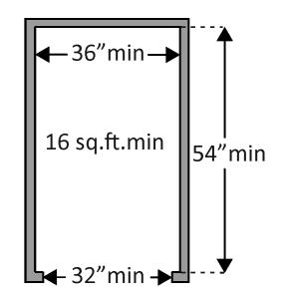

30

Chapter 3: Internal Service & Facilities

9. Inside the Building

 |  | Y/N | Standard |  |  |  |  | Reference | Recommendation
9.27 | If there is a LULA elevator, is the | □Yes
 | interior: | □No
 | At least 51 inches deep by 51 inches | ______
 | wide with a door opening width of at
 | least 36 inches? | □Yes
 | Or | □Yes
 | Or | □No
 | At least 54 inches deep by at least 36 | □No
 | inches wide with at least 15 sq. ft. of | ______
 | clear floor area and a door opening
 | width of at least 32 inches?
9.28 | If there is an elevator, are the control | □Yes
 | buttons: | □No
 |  | ______
 | No less than 15 inches and no greater 42 | ______ |  |  | 42” max
 | inches above the floor?
 | Or | □Yes
 | Up to 48 inches above the floor for a | □Yes
 | Up to 48 inches above the floor for a | □Yes |  |  | 48” max
 | parallel approach? | □No
 |  | ______
9.29 | If there is an elevator: | □Yes
 | Are the car control buttons designated | □No
 | with raised characters?
 | Are the car control buttons designated | □Yes
 | Are the car control buttons designated | □No
 | with Braille? | □No
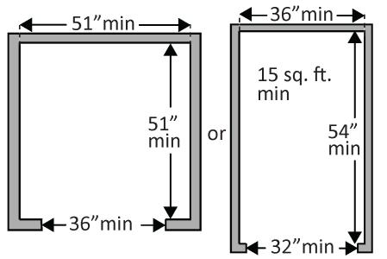
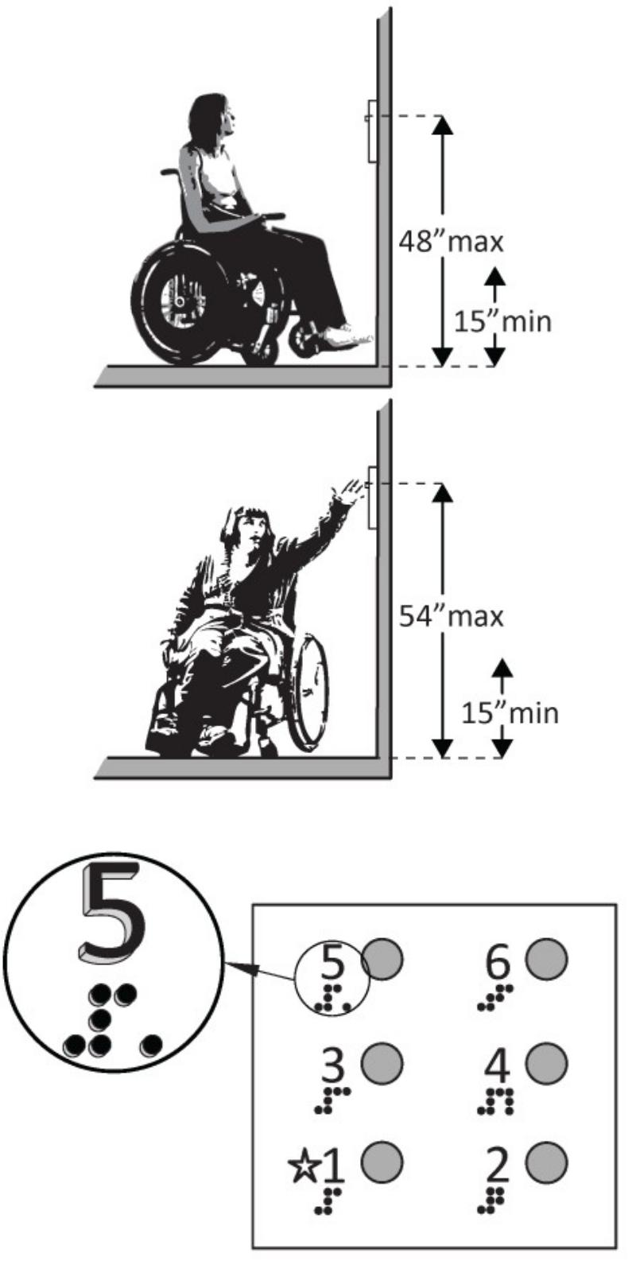

31

Chapter 3: Internal Service & Facilities

9. Inside the Building

 |  | Y/N | Standard | Reference | Recommendation
9.30 | If there is an elevator, are there audible | □Yes
 | signals which sound as the car passes or | □No
 | is about to stop at a floor?
 | Or, visual signals | □Yes
 | Or, visual signals | □No
9.31 | If there is an elevator:
 | Is there a sign on both door jambs at every | □Yes
 | floor identifying the floor? | □No
 | Is there a tactile star on both jambs at the | □Yes
 | main entry level? | □No
 | Do text characters contrast with their | □Yes
 | backgrounds? | □No
 | Are text characters raised? Is there Braille? | □Yes
 |  | □No
 | Is the sign mounted between 48 inches to | □Yes
 | the baseline of the lowest character and | □No
 | 60 inches to the baseline of the highest | □No
 | character above the floor? | ______
9.32 | If there is a full size or LULA elevator, | □Yes
 | are there horizontal grab bars? | □No
 | At the maximum height of 3 feet | □Yes
 |  | □No
 |  |  |  |  | 32
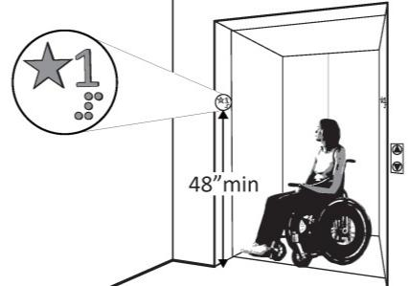
Chapter 3: Internal Service & Facilities

9. Inside the Building

 |  |  | Y/N | Standard |  | Reference | Recommendation
 | Signs “Tactile characters” are read using touch, i.e. raised characters and Braille.
9.33 | If there are signs that provide direction to |  | □Yes
 | or information about interior spaces: |  | □No
 | Do text characters contrast with their |  | □No
 | backgrounds?
 | Is the sign mounted so that characters are |  | □Yes
 |  |  | □No
 | at least 40 inches above the floor?
9.34 | If there are signs designating permanent |  | □Yes
 | rooms and spaces not likely to change |  | □No
 | over time, |  | □No
 | e.g. room numbers and letters, room
 | names, and exit signs: |  | □Yes
 | Do text characters contrast with their |  | □Yes
 |  |  | □No
 | backgrounds?
 | Are text characters raised? |  | □Yes
 |  |  | □No
 | Is there Braille? |  | □Yes
 |  |  | □No
 | Is the sign mounted: |  | □Yes
 | On the wall on the latch side of the door? |  | □No
 | Note: Signs are permitted on the push side
 | of doors with closers and without hold-
 | open devices.
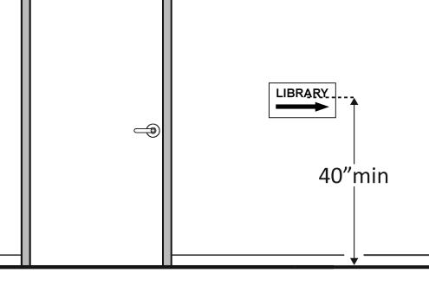

33

Chapter 3: Internal Service & Facilities

9. Inside the Building

 |  | Y/N | Standard | Reference | Recommendation
 | With clear floor space beyond the arc of | □Yes
 | the door swing between the closed | □No
 | position and 45-degree open position, at | □No
 | least 18 x 18 inches centered on the tactile | _____
 | characters?
 | So the baseline of the lowest character is | □Yes
 | at least 48 inches above the floor and the | □No
 | baseline of the highest character is no | _____
 | more than 60 inches above the floor? | _____
 | Note: If the sign is at double doors with
 | one active leaf, the sign should be on the
 | inactive leaf; if both leaves are active, the
 | sign should be on the wall to the right of
 | the right leaf.
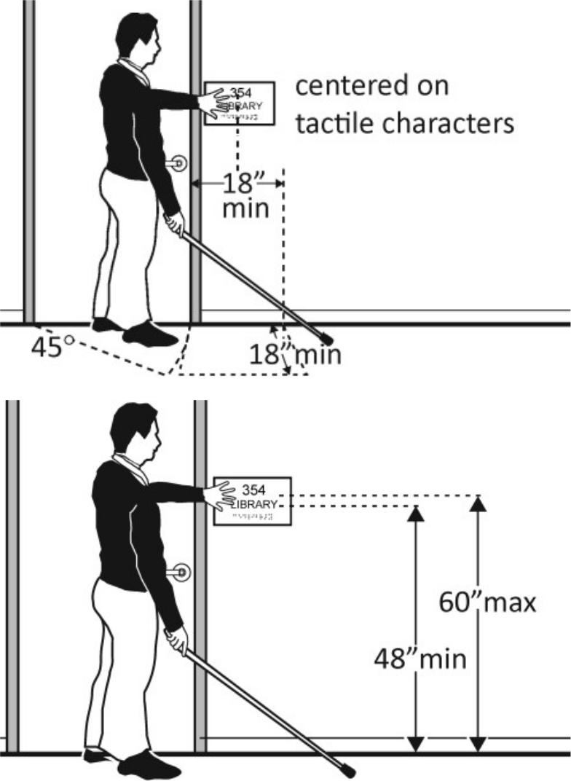

34

Chapter 3: Internal Service & Facilities

10. Equipment control and uses

 | Y/N | Standard | Reference | Recommendation

 | Controls – light switches, security and intercom systems, emergency/alarm boxes, etc.
10.1 | Is there a clear floor space at least 30 |  | □Yes
 | inches wide by at least 48 inches long for a |  | □No
 | forward or parallel approach?
 |  |  | ______
 | Are the operable parts no higher than 48 |  | □Yes
 | inches above the floor?* |  | □No
 |  |  | ______
10.2 | Can the control be operated with one |  | □Yes
 | hand and without tight grasping, pinching, |  | □No
 | or twisting of the wrist?
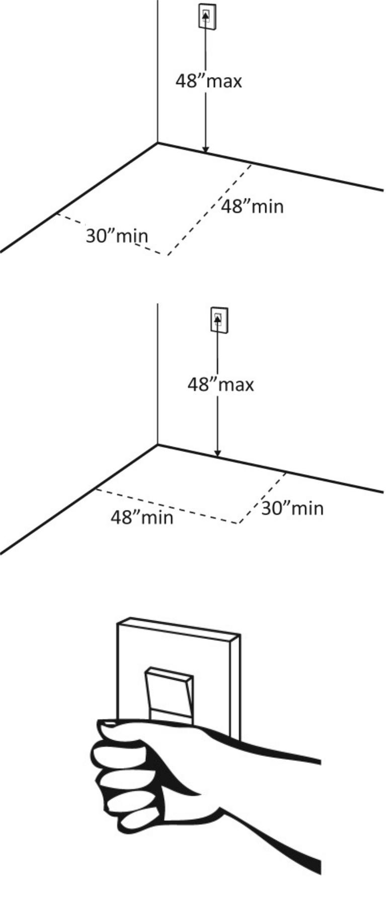

35

Chapter 3: Internal Service & Facilities

11. Service

 |  |  | Y/N | Standard | Reference | Recommendation
Drinking facilities
11.1 Can the water spout be easily maneuvered |  |  | □Yes
by a person in a wheelchair? (30 to 36 |  |  | □No
inches from ground level ) |  |  | □No


11.2 Is the surface non-slippery? | □Yes
 | □No

36

Chapter 3: Internal Service & Facilities

11. Service

 | Y/N | Standard | Reference | Recommendation

 | Seating: At dining surfaces (restaurants, cafeterias, bars, etc.) and non-employee work surfaces (libraries, conference rooms, etc.)
11.3 | Are at least 5%, but no fewer than one, of |  | □Yes
 | seating and standing spaces accessible for |  | □No
 | people who use wheelchairs? |  | Total:
 |  |  | Wheel-
 |  |  | Chairs:
11.4 |  | Is there a route at least 36 inches wide | □Yes
 |  | to accessible seating? | □No
 |  |  | ______
11.5 | At the accessible space(s), is the top of the |  | □Yes
 | accessible surface no less than 28 inches |  | □No
 | and no greater than 34 inches above the |  | □No
 | floor? |  | ______
 | Note: If for children, the top should be no
 | less than 26 inches and no greater than 30
 | inches above the floor.
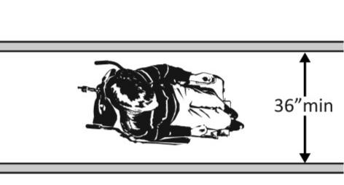
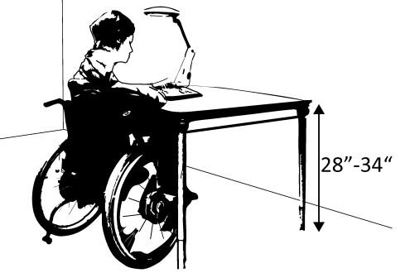

37

Chapter 3: Internal Service & Facilities

11. Service


Y/N | Standard | Reference | Recommendation

11.6 | Is there a clear floor space at least 30 |  | □Yes
 | inches wide by at least 48 inches long for a |  | □No
 | forward approach? |  | ______
 | Does it extend no less than 17 inches and |  | □Yes
 | no greater than 25 inches under the |  | □No
 | surface? |  | ______
 | Is there knee space at least 27 inches high |  | □Yes
 | and at least 30 inches wide? |  | □No
 |  |  | ______
 | Note: If for children, the knee space may |  | □Yes
 | be 24 inches high. |  | □No
 |  |  | ______
 | Seating: General – reception areas, waiting rooms, etc.
11.7 | Is there at least one space at least 36 |  | □Yes
 | inches wide by at least 48 inches long for a |  | □No
 | person in a wheelchair?
 |  |  | ______
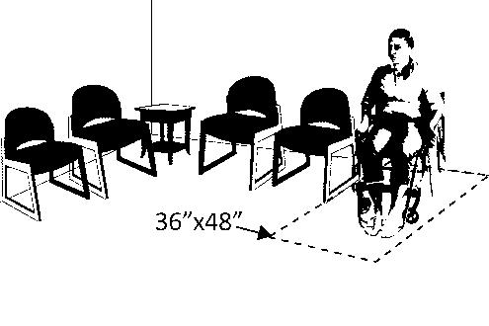

38

Chapter 3: Internal Service & Facilities

11. Service (Health)

 |  |  |  | Y/N | Standard | Reference | Recommendation
 | Examination rooms and Medical equipment
11.8 | Is there clear floor space available for a |  |  | □Yes
 | person in a wheelchair to turn around, i.e. |  |  | □Yes
 | a circle at least 60 inches in diameter or a |  |  | □No
 | T-shaped space within a 60-inch square? |  |  | ______
11.9 | Is clear floor space (2’-6” by 4’-0” |  |  | □Yes
 | minimum) available adjacent to the exam |  |  | □Yes
 | table or chair and adjoining the accessible |  |  | □No
 | route which allows a transfer from a |  |  | ______
 | wheelchair?
11.10 | Are accessible weight scales available that |  |  | □Yes
 | can be used to weigh people using |  |  | □No
 | wheelchairs and similar types of mobility |  |  | □No
 | aids?
11.11 | Are examination tables available that |  |  | □Yes
 | provide adjustable transfer heights (range |  |  | □No
 | of 17”-18”); adequate dimensions for
 | transfer surface (minimum width of 2’-6”
 | and depth of 1’-3”; and removable/
 | repositionable support rails to allow
 | wheelchair users to transfer onto and off
 | of the exam table?
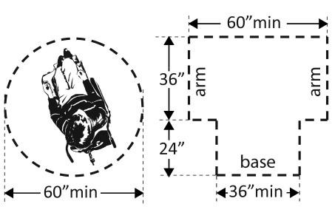

39

Chapter 3: Internal Service & Facilities

11. Service (Health)

 | Y/N | Standard | Reference | Recommendation

 | Patient Sleeping Room
11.12 | Are there at least 10% (but no fewer than |  |  | □Yes
 | one) patient sleeping rooms that provide |  |  | □No
 | the mobility features.
 |  |  |  | ______
11.13 | If your facility is a long-term care facility, |  |  | □Yes
 | do a mini-mum of 50% of rooms provide |  |  | □No
 | the mobility features.
 |  |  |  | ______
11.14 | Is there a minimum 2’-6” x 4’-0” clear |  |  | □Yes
 | maneuvering space on both sides of the |  |  | □No
 | bed(s)?
11.15 | Is there clear floor space available for a |  |  | □Yes
 | person in a wheelchair to turn around, i.e. |  |  | □Yes
 | a circle at least 60 inches in diameter or a |  |  | □No
 | T-shaped space within a 60-inch square? |  |  | ______
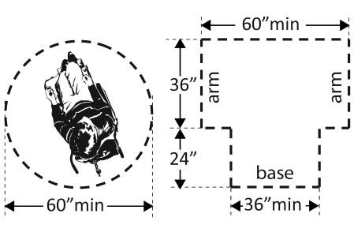

40

Chapter 3: Internal Service & Facilities

11. Service (Education)

 | Y/N | Standard | Reference | Recommendation

 | Class Room
11.16 | Accessible paths within the classroom are |  |  | □Yes
 | wide enough to allow 2’-8” of clearance |  |  | □No
 | while students are seated at the adjacent |  |  | □No
 | seats. |  |  | ______
^{11.17} Is there clear floor space available for a |  |  |  | □Yes
 | person in a wheelchair to turn around, i.e. |  |  | □Yes
 | a circle at least 60 inches in diameter or a |  |  | □No
 | T-shaped space within a 60-inch square? |  |  | ______
11.18 | Are there at least 4% (but no fewer than |  |  | □Yes
 | one) accessible seats. |  |  | □No
 |  |  |  | ______
11.19 | Is the Accessible seating interspersed with |  |  | □Yes
 | the standard seating, including the front, |  |  | □No
 | middle, and back of the class room.
 | (This accommodates individual learning
 | styles and preferences as well as mobility
 | limitations.)

41

Chapter 3: Internal Service & Facilities

11. Service (Education)

 |  | Y/N | Standard | Reference | Recommendation
11.20 | Is the Seat height between 1’-5”-1’-7” | □Yes
 | from the floor. | □No
 |  | ______
11.21 | Is Maximum distance between the seat | □Yes
 | back and writing surface at least 1’-6” | □No
 |  | ______
11.22 | Do Seats provide supported seat depth of | □Yes
 | at least 1’-6”. | □No
 |  | ______
11.23 | Is the lower edge of Wall-mounted | □Yes
 | black/white boards more than 2’-6” from | □No
 | the floor.
 |  | ______

42

Chapter 3: Internal Service & Facilities

11. Service (Corporate)

 | Y/N | Standard | Reference | Recommendation

 | Automated Teller Machines (ATM)
11.24 | Is there sufficient clear floor space (2’-6” |  |  | □Yes
 | by 4’-0” minimum) adjacent to the ATM to |  |  | □No
 | allow for forward or parallel approach by a |  |  | □No
 | wheelchair?
11.25 | Is the maximum height of all operable |  |  | □Yes
 | parts (controls, buttons, deposit slots, etc.) |  |  | □No
 | 4’-0” from ground surface?
11.26 | Are operable parts usable with one hand |  |  | □Yes
 | and do not require tight grasping pinching |  |  | □No
 | or twisting of the wrist?
11.27 | Can each operable part be differentiated |  |  | □Yes
 | by sound or touch without activation? |  |  | □No

43

Chapter 3: Internal Service & Facilities

11. Service (Food and Accommodation )

 | Y/N | Standard | Reference | Recommendation

 | Counter
11.28 | Is at least one section of the counter |  |  | □Yes
 | higher than 3’-0” by 2’-6” wide |  |  | □No
11.29 | Are displays accessible and mounted on |  |  | □Yes
 | surfaces no higher than 3’-0” from the |  |  | □No
 | floor. |  |  | □No
11.30 | Are overhead display shelves higher than |  |  | □Yes
 | 4’-1” |  |  | □No
11.31 | Are Cutlery, condiments, and napkin |  |  | □Yes
 | containers etc., mounted higher than 3’-6” |  |  | □Yes
 | from floor level. |  |  | □No

44

Chapter 3: Internal Service & Facilities

11. Service (Commercial)

 |  |  | Y/N |  |  | Standard | Reference | Recommendation
 | Check-Out Aisles – supermarkets, large retail stores, etc.
11.32 |  | Is the aisle at least 36 inches wide? | □Yes
 |  |  | □No
 |  |  | ______
11.33 | Is the counter surface of at least one aisle |  | □Yes
 | no higher than 38 inches above the floor? |  | □No
 |  |  | ______
11.34 | Is the top of the counter edge protection |  | □Yes
 | no higher than 2 inches above the counter |  | □No
 | surface?
 |  |  | ______
11.35 | If there is a check writing surface, is the |  | □Yes
 | top no less than 28 inches and no greater |  | □No
 | than 34 inches above the floor?
 |  |  | ______
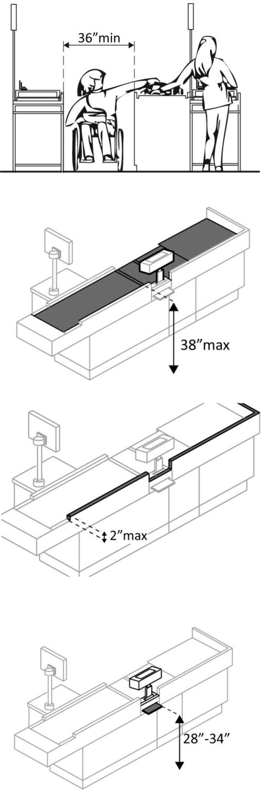

45

Chapter 3: Internal Service & Facilities

11. Service (Commercial)

 |  |  | Y/N | Standard |  |  | Reference | Recommendation
 | Sales & Service Counters – banks, stores, dry cleaners, auto repair shops, fitness clubs, etc.
11.36 | Is there a portion of at least one of each |  | □Yes
 | type of counter that is: |  | □No
 | No higher than 36 inches above the floor? |  | ______
 | At least 36 inches long? |  | □Yes
 |  |  | □No
 |  |  | ______
11.37 | Does at least one of each type of self- |  | □Yes
 | service shelf or dispensing device for |  | □No
 | tableware, dishware, condiments, food |  | □No
 | and beverages have a forward or parallel |  | □Fwd
 | approach? |  | □Fwd
 |  |  | □Pll
11.38 | If there is an unobstructed parallel |  | □Yes
 | approach, is the shelf or dispensing device |  | □Yes
 | no higher than 48 inches above the floor? |  | □No
 |  |  | ______
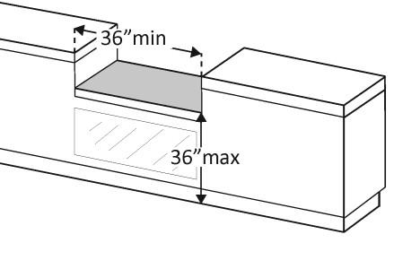
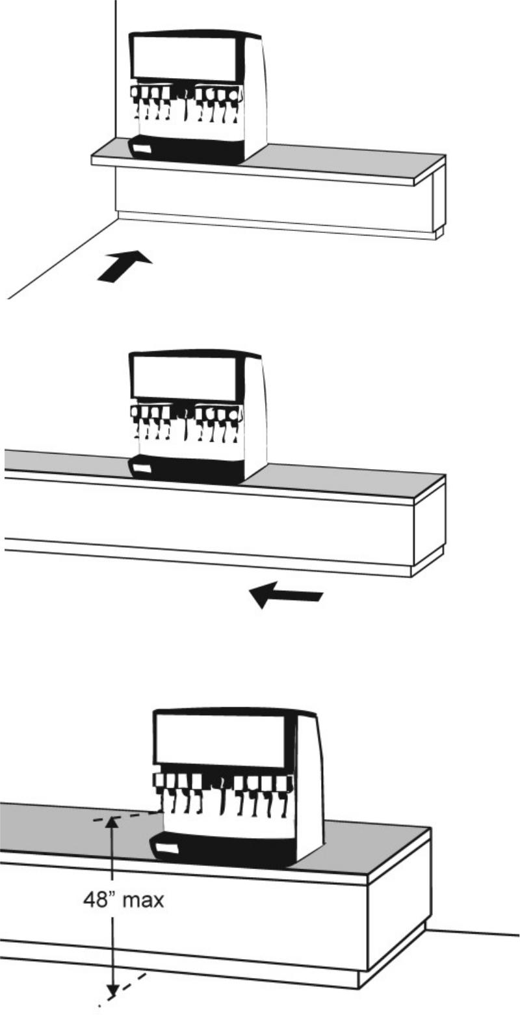

46

Chapter 3: Internal Service & Facilities

11. Service (Recreation & Entertainment)

 | Y/N | Standard | Reference | Recommendation

 | Seating: Assembly Areas – theaters, auditoriums, stadiums, theater style classrooms, etc.
11.39 | If stage/podium is provided in assembly |  | □Yes
 | area, is there provision of ramp? |  | □No
 | Is the ramp accessible? |  | □Yes
 |  |  | □No
11.40 | Are an adequate number of wheelchair |  | □Yes |  | Total Space |  | Accessible
 | spaces provided? |  | □No |  |  |  | Space
 |  |  | □No |  | 4 – 25 |  | 1
 | Note: 5% of seats must be separated for |  | Total:
 |  |  | Total: | 26 - 50 |  |  | 2
 | person with disability.
 |  |  | Wheel- |  | 51 – 150 |  | 4
 |  |  | Chairs:
 |  |  | Chairs: | 151 - 300 |  |  | 5
11.41 | Are wheelchair spaces dispersed to allow |  | □Yes
 | location choices and viewing angles |  | □No
 | equivalent to other seating, including |  | □No
 | specialty seating areas that provide
 | distinct services and amenities?
11.42 | Where people are expected to stand, do |  | □Yes
 | people in wheelchair spaces have a clear |  | □No
 | line of sight over and between the heads |  | □No
 | of others in front of them?
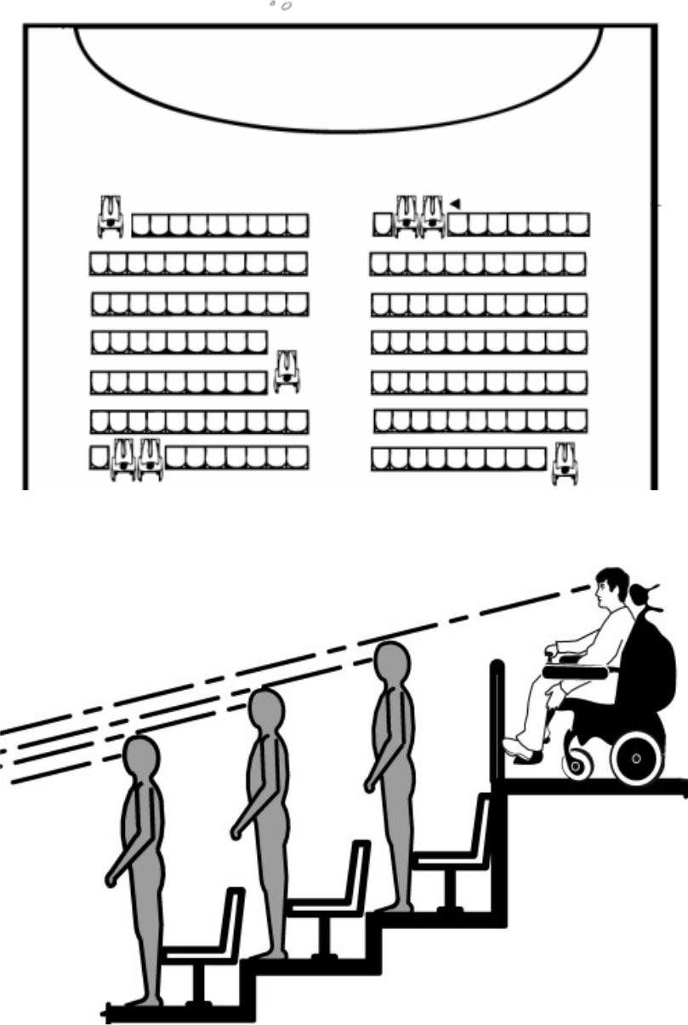

47

Chapter 3: Internal Service & Facilities

11. Service (Recreation & Entertainment)

 |  | Y/N | Standard | Reference | Recommendation
11.43 | If there is a single wheelchair space, is it at | □Yes
 | least 36 inches wide? | □No
 |  | ______
11.44 | If the wheelchair space can be entered | □Yes
 | from the front or rear, is it at least 48 | □No
 | inches deep? | □No
 |  | ______
11.45 | If the wheelchair space can only be | □Yes
 | entered from the side, is it at least 60 | □No
 | inches deep? | □No
 |  | ______
11.46 | Do wheelchair spaces adjoin, but not | □Yes
 | overlap, accessible routes? | □No
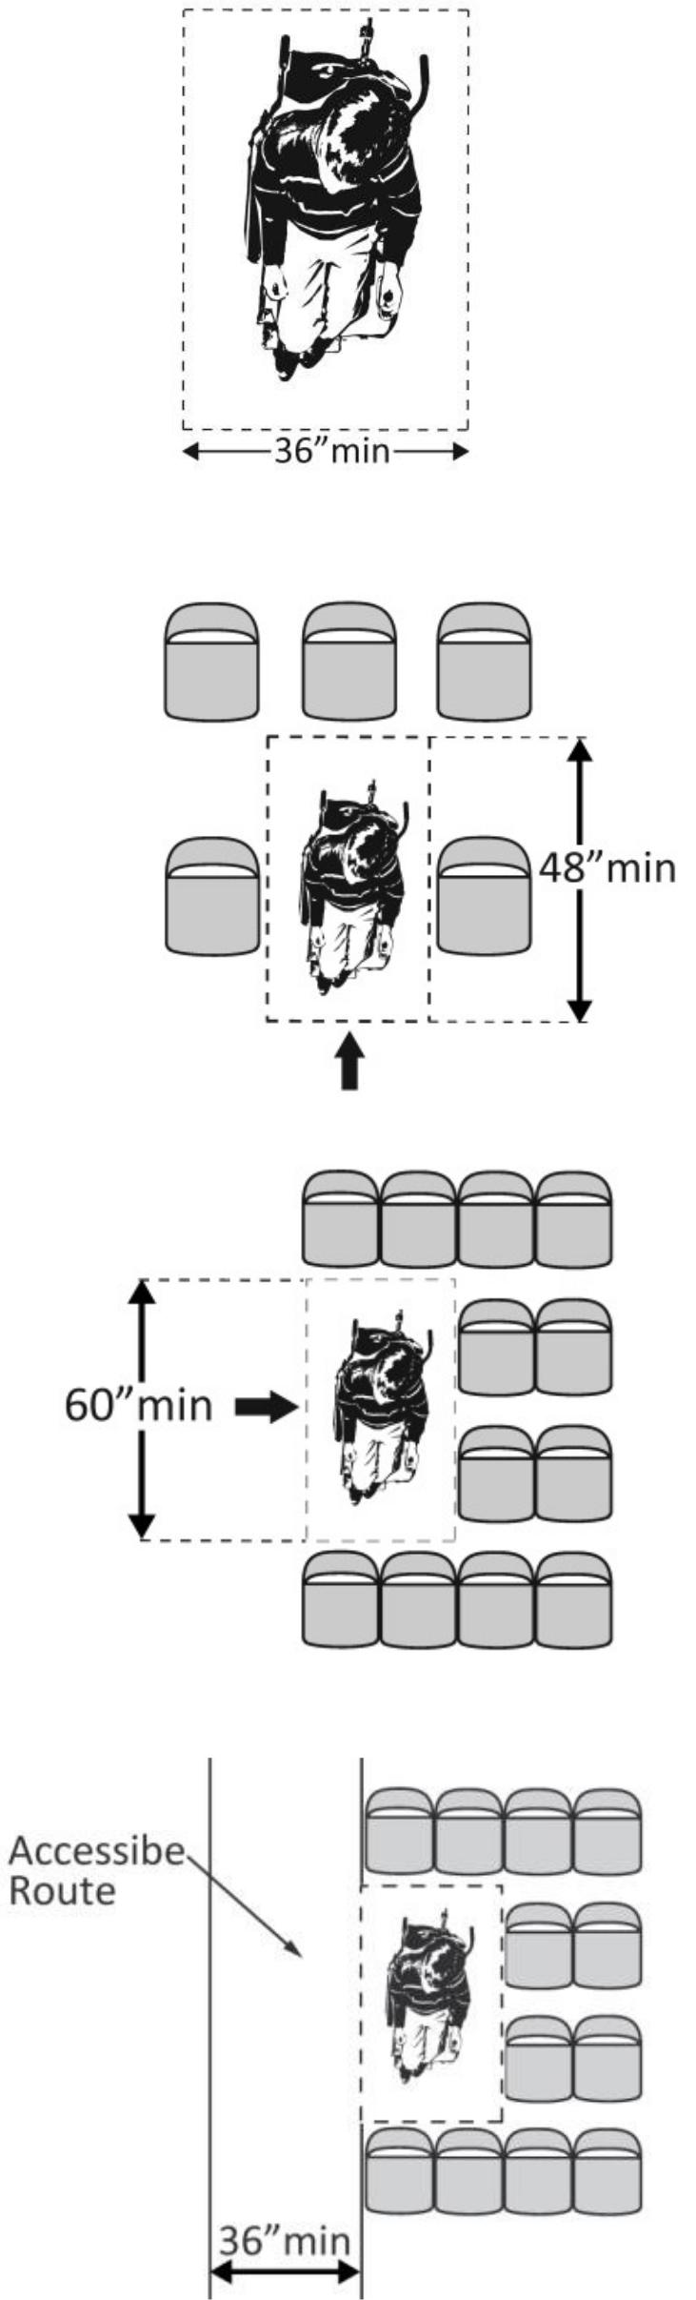

48

Chapter 3: Internal Service & Facilities

11. Service (Transportation)

 |  |  |  | Y/N | Standard | Reference | Recommendation
11.47 | Are tactile features provided? |  |  | □Yes
 |  |  |  | □No
11.48 | Does the traffic light has specific siren to |  |  | □Yes
 | inform when lights are changed. |  |  | □No
 | Crosswalks
11.49 | Is Curb ramp provided at each end of the |  |  | □Yes
 | walkway where sidewalks are provided, or |  |  | □No
 | wherever level differences of more than |  |  | □No
 | 19 mm
11.50 | Are the crosswalks at least 10’-0”wide and |  |  | □Yes
 | clearly marked by 4” painted white lines, |  |  | □No
 | or by using distinctive, highly contrasting |  |  | □No
 | paving materials.
11.51 | Are audible and flashing crossing signals |  |  | □Yes
 | provided |  |  | □No

49

Chapter 3: Internal Service & Facilities

11. Service (Transportation)

 |  |  |  | Y/N | Standard | Reference | Recommendation
 | Paths, Sidewalks and Walkways
11.52 | Is curb ramp provided wherever there is a |  |  | □Yes
 | level difference between the sidewalk, or |  |  | □No
 | pedestrian pathway, and the road surface |  |  | □No
 | at all street corners, or wherever
 | pedestrian crosswalks are provided
11.53 | Is the curb ramp minimum of 5’-0” wide |  |  | □Yes
 |  |  |  | □No
11.54 | Does the slope of curb ramps exceed 1:20. |  |  | □Yes
 |  |  |  | □No

50

Chapter 3: Internal Service & Facilities

11. Service (Transportation)

 |  |  |  | Y/N | Standard | Reference | Recommendation
 | Bus Stop
11.55 | Are Waiting areas at bus stops in/of level |  |  | □Yes
 | and firm materials. |  |  | □No
11.56 | Does it accommodate waiting persons. At |  |  | □Yes
 | least 6’-8" mm wide by 40’-0” long |  |  | □No
11.57 | Is Bus stop area free of all street furniture, |  |  | □Yes
 | e.g., dispensers, vending machines, waste |  |  | □No
 | boxes, planters, posts, signs and guy wires. |  |  | □No

51

Chapter 3: Internal Service & Facilities

11. Service (Transportation)

 |  |  |  | Y/N | Standard | Reference | Recommendation
 | Bus
11.58 | Is there mechanical system to elevate |  |  | □Yes
 | wheelchairs? |  |  | □No
11.59 | Is the seat accessible?? |  |  | □Yes
 |  |  |  | □No
 |  |  |  | _______
11.60 | Is there audible and visible information |  |  | □Yes
 | indicating different stops (location)? |  |  | □No
11.61 | Is there alarm for stopping the bus? |  |  | □Yes
 |  |  |  | □No
 | Is the alarm accessible |  |  | □Yes
 |  |  |  | □No

52

Chapter 3: Internal Service & Facilities

11. Service (Sports & Fitness)
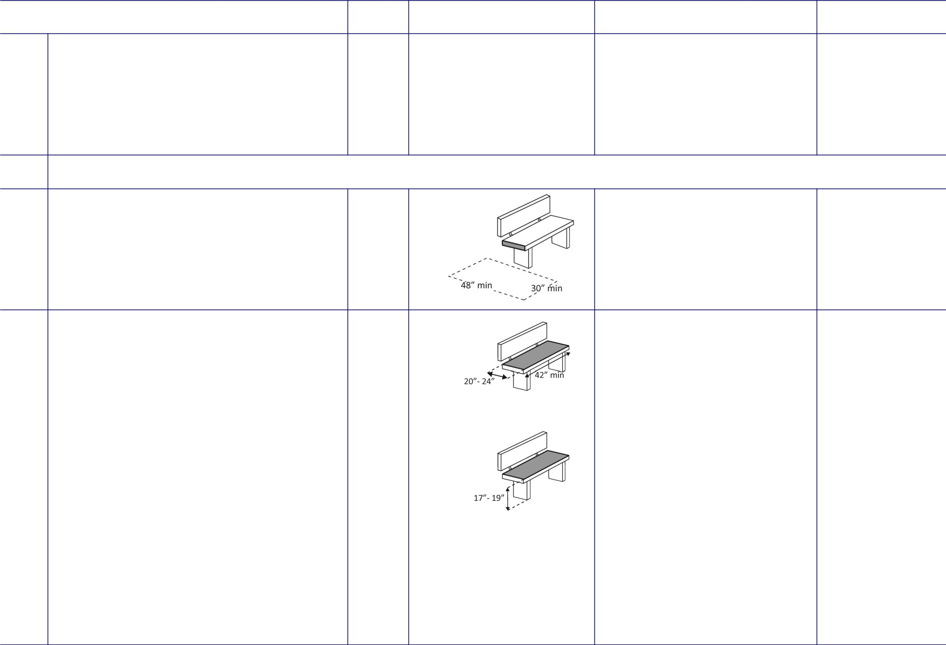

 |  | Y/N |  | Standard | Reference | Recommendation
11.62 | Is the facility accessible for watching and | □Yes
 | playing games | □No
 |  | ______

Benches – In locker rooms, dressing rooms, fitting rooms This section does not apply to any other benches

11.63 | In locker rooms, dressing rooms and | □Yes
 | fitting rooms, is there at least one room | □No
 | with a bench?
 |  | ______

11.64 | Is there a clear floor space at least 30 | □Yes
 | inches wide by at least 48 inches long at | □No
 | the end of the bench and parallel to the | _____
 | short axis of the bench? | _____
 | Is the bench seat at least 42 inches long | □Yes
 | Is the bench seat at least 42 inches long | □No
 | and no less than 20 inches and no greater | □No
 | than 24 inches deep? | _____
 | Does the bench have back support or is it | □Yes
 | affixed to a wall? | □No
 |  | _____
 | Is the top of the bench seat no less than | □Yes
 | 17 inches and no greater than 19 inches | □Yes
 | 17 inches and no greater than 19 inches | □No
 | above the floor? | □No
 | above the floor? | _____

53
Chapter 3: Internal Service & Facilities

11. Service (Other)

 |  |  |  | Y/N | Standard | Reference | Recommendation
 | Picnic Spots
11.65 | Are some picnic tables and benches |  |  | □Yes
 | located near accessible paths and |  |  | □No
 | walkways? |  |  | □No
11.66 | Are the accessible picnic tables or benches |  |  | □Yes
 | available in a variety of sunny and shady |  |  | □No
 | locations?
11.67 | Dose the design of picnic tables allow |  |  | □Yes
 | persons using mobility aids to approach |  |  | □No
 | them from one or both ends and provide |  |  | □No
 | adequate knee and armrest clearance.
11.68 | Are garbage cans, barbecues and |  |  | □Yes
 | woodpiles etc., located adjacent to |  |  | □No
 | accessible picnic areas, |  |  | □No
 | and approachable and useable by persons
 | using mobility aids.

54

Chapter 3: Internal Service & Facilities

11. Service (Other)

 |  |  |  | Y/N | Standard | Reference | Recommendation
 | Playground
11.69 | Are the play areas and recreational |  |  | □Yes
 | equipment, or other amenities designed |  |  | □Yes
 | to be accessible and useable by children |  |  | □No
 | with varying abilities/ disabilities?
11.70 | Are the park benches or seating areas |  |  | □Yes
 | readily available for children and older |  |  | □No
 | persons? |  |  | □No
11.71 | Where planting beds are provided, is the |  |  | □Yes
 | use of raised beds, fragrant planting |  |  | □No
 | materials, and Braille signage considered? |  |  | □No
11.72 | Are all garbage containers, light standards, |  |  | □Yes
 | or other obstructions located to one side |  |  | □No
 | of all paths and/or active playing areas?

55

Chapter 3: Internal Service & Facilities

11. Service (Other)

 |  |  |  | Y/N | Standard | Reference | Recommendation
 | Play-space
11.73 | Are play areas separated by age |  |  | □Yes
 | appropriate equipment? |  |  | □No
 | Junior area for children under 5 years of
 | age and a senior area for children 5-12
 | years of age.
11.74 | Is diversity of play components chosen |  |  | □Yes
 | carefully to engage multiple senses, |  |  | □No
 | develop skills and encourage social |  |  | □No
 | interaction?
11.75 | Are the play components are to be linked |  |  | □Yes
 | to an accessible route through the |  |  | □No
 | playground? |  |  | □No
 | minimum of 50% for small playgrounds
 | (10 or less play components)
 | 75% for larger playgrounds.

56

Chapter 3: Internal Service & Facilities

11. Service (Other)

 |  |  |  | Y/N | Standard | Reference | Recommendation
 | Landscape Materials and Planting
11.76 | Are Landscape materials, trees, shrubs, |  |  | □Yes
 | and plants selected and located with a |  |  | □No
 | wide variety of disabled users in mind? |  |  | □No
 | plants and shrubs with a variety of
 | fragrances
 | plants with thorns or heavy berries
 | avoided in active pedestrian locations.
11.77 | Are planting bed edges, a minimum of 4 |  |  | □Yes
 | inches high? |  |  | □No
11.78 | Is there a minimum 6’-6” clear headroom |  |  | □Yes
 | over the walking space ? |  |  | □No
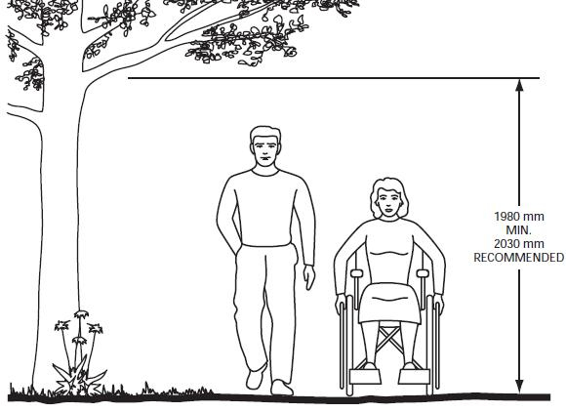

57

Chapter 3: Internal Service & Facilities

12. Sanitary Facilities

 |  |  |  | Y/N | Standard | Reference | Recommendation
12.1 | If toilet rooms are available to the public, |  |  | □Yes
 | is at least one toilet room accessible? |  |  | □No
 | (Either one for each sex, or one unisex.) |  |  | □No
12.2 | If not all toilet rooms are accessible, is |  |  | □Yes
 | there a sign at the accessible toilet room |  |  | □No
 | with the International Symbol of
 | Accessibility
 | Accessible route
12.3 | Is there an accessible route to the |  |  | □Yes
 | accessible toilet room? |  |  | □No
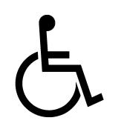

58

Chapter 3: Internal Service & Facilities

12. Sanitary Facilities

 |  |  |  | Y/N | Standard | Reference | Recommendation
 | Signage
12.4 |  | Do text characters contrast with their |  | □Yes
 |  | backgrounds? |  | □No
 |  | Are text characters raised? |  | □Yes
 |  |  |  | □No
 |  | Is there Braille? |  | □Yes
 |  |  |  | □No
 |  | Is the sign mounted: |  | □Yes
 |  | On the wall on the latch side of the |  | □No
 |  | door?
 |  | With clear floor space beyond the arc of |  | □Yes
 |  | the door swing between the closed |  | □No
 |  | position and 45-degree open position, at |  | □No
 |  | least 18 x 18 inches centered on the
 |  | tactile characters?
 |  | So the baseline of the lowest character |  | □Yes
 |  | is at least 48 inches above the floor and |  | □No
 |  | the baseline of the highest character is
 |  | no more than 60 inches above the |  | _____:
 |  | floor?
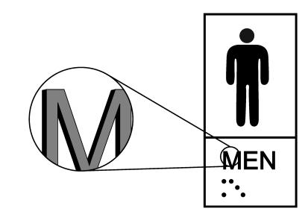
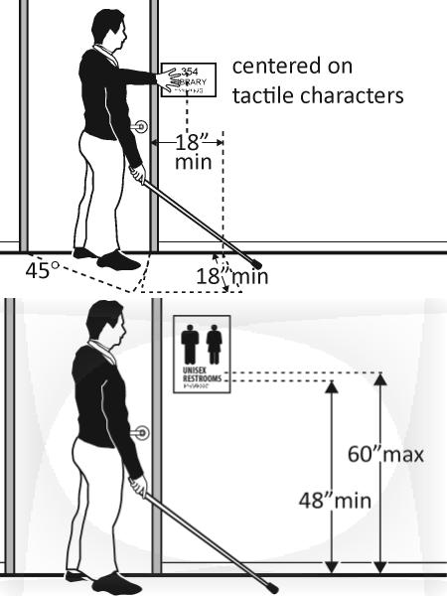

59

Chapter 3: Internal Service & Facilities

12. Sanitary Facilities

 |  |  |  | Y/N | Standard | Reference | Recommendation
 | Entrance
12.5 | Is the entrance barrier free? |  |  | □Yes
 |  |  |  | □No
12.6 |  | Is the door opening width at least 32 |  | □Yes
 |  | inches clear, between the face of the |  | □No
 |  | door and the stop, when the door is |  | □No
 |  | open 90 degrees? |  | ______
12.7 | the pull side of the door is there at least |  |  | □Yes
 | 18 inches of maneuvering clearance |  |  | □No
 | beyond the latch side plus 60 inches clear |  |  | □No
 | depth? |  |  | ______
 | On both sides of the door, is the floor |  |  | □Yes
 |  |  |  | □No
 | surface of the maneuvering clearance |  |  | □No
 | level (no steeper than 1:48)? |  |  | ______
12.8 | If the threshold is vertical is it no more |  |  | □Yes
 | than ¼ inch high? |  |  | □No
 |  |  |  | ______
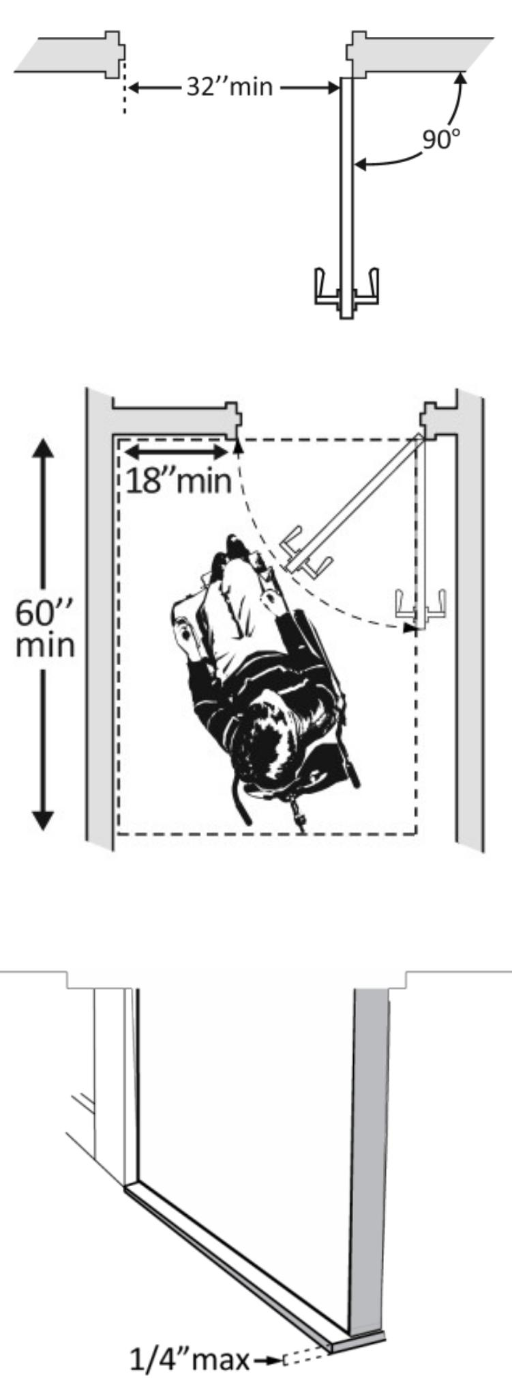

60

Chapter 3: Internal Service & Facilities

12. Sanitary Facilities

 |  | Y/N | Standard | Reference | Recommendation
12.9 | Is the door equipped with hardware that | □Yes
 | is operable with one hand and does not | □No
 | require tight grasping, pinching or
 | twisting of the wrist? | □Yes
 | Door handle? | □Yes
 | Door handle? | □No
 | Lock (if provided)? | □Yes
 |  | □No
12.10 | Are the operable parts of the door | □Yes
 | hardware no less than 34 inches and no | □No
 | greater than 48 inches above the floor or | □No
 | ground surface? | ______
12.11 | Can the door be opened easily (5 pounds | □Yes
 | maximum force)? | □No
 | Note: You can use a pressure gauge or fish | ______
 | scale to measure force. If you do not have
 | one you will need to judge whether the
 | door is easy to open.
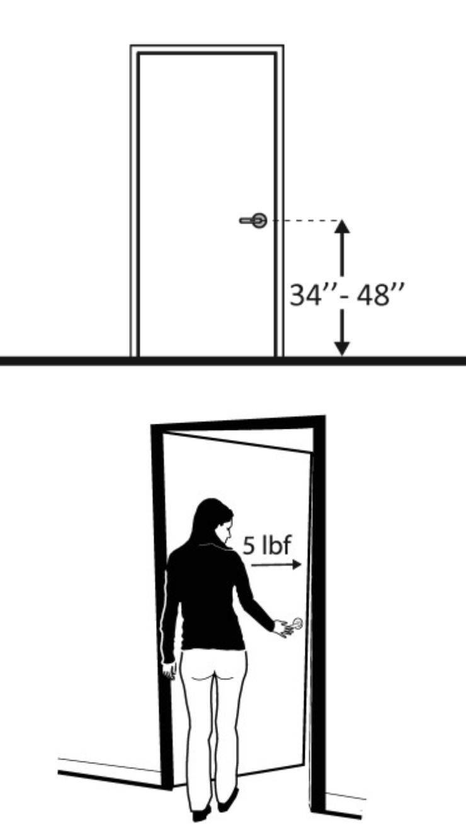

61

Chapter 3: Internal Service & Facilities

12. Sanitary Facilities

 |  | Y/N | Standard | Reference | Recommendation
12.12 | If the door has a closer, does it take at | □Yes
 | least 5 seconds to close from an open | □No
 | position of 90 degrees to a position of 12 | □No
 | degrees from the latch? | ______
12.13 | If there is a privacy wall and the door | □Yes
 | swings out, is there at least 24 inches of | □No
 | maneuvering clearance beyond the door | □No
 | latch side and 42 inches to the privacy | ______
 | wall?
12.14 | If there is a privacy wall and the door | □Yes
 | swings in, is there at least 24 inches of | □No
 | maneuvering clearance beyond the door | □No
 | latch side and at least 48 inches to the | ______
 | privacy wall if there is no door closer or at
 | least 54 inches if there is a door closer?
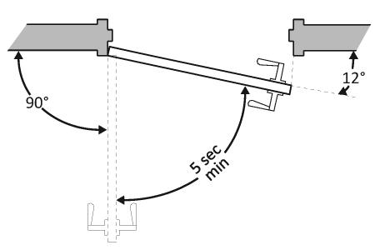
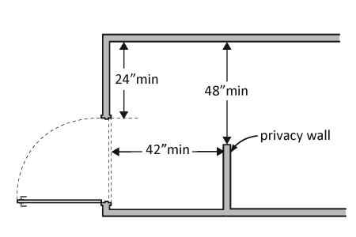
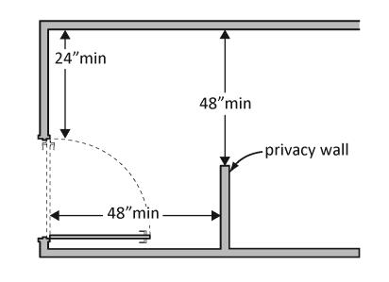

62

Chapter 3: Internal Service & Facilities

12. Sanitary Facilities

 | Y/N | Standard | Reference | Recommendation

 | Inside Toilet
12.15 |  | Is there a clear path to at least one of |  | □Yes
 |  | each type of fixture, e.g. lavatory, hand |  | □No
 |  | dryer, etc., that is at least 36 inches
 |  | wide? |  | ______
^{12.16} Is there clear floor space available for a |  |  |  | □Yes
 | person in a wheelchair to turn around, i.e. |  |  | □Yes
 | a circle at least 60 inches in diameter or a |  |  | □No
 | T-shaped space within a 60-inch square? |  |  | ______
12.17 | In a single user toilet room if the door |  |  | □Yes
 | swings in and over a clear floor space at |  |  | □No
 | an accessible fixture, is there a clear floor |  |  | □No
 | space at least 30 x 48 inches beyond the |  |  | ______
 | swing of the door?
12.18 | If the mirror is over a lavatory or |  |  | □Yes
 | countertop, is the bottom edge of the |  |  | □No
 | reflecting surface no higher than 40 inches |  |  | □No
 | above the floor? |  |  | ______
 | *34 inches for children
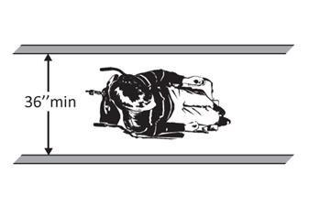
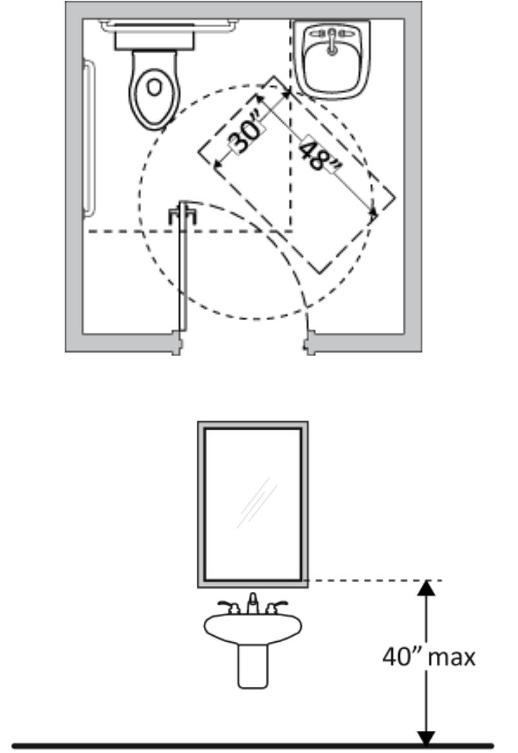

63

Chapter 3: Internal Service & Facilities

12. Sanitary Facilities

 | Y/N | Standard | Reference | Recommendation

 | Lavatories
12.19 |  | Does at least one lavatory have a clear |  | □Yes
 |  | floor space for a forward approach at |  | □No
 |  | least 30 inches wide and 48 inches long? |  | □No
 |  |  |  | ______
12.20 | Is the front of the lavatory or counter |  |  | □Yes
 | surface, whichever is higher, no more than |  |  | □No
 | 34 inches above the floor?
 |  |  |  | ______
12.21 | Is there at least 27 inches clearance from |  |  | □Yes
 | the floor to the bottom of the lavatory |  |  | □No
 | that extends at least 8 inches under the |  |  | □No
 | lavatory for knee clearance? |  |  | ______
12.22 | Can the faucet be operated without tight |  |  | □Yes
 | grasping, pinching, or twisting of the |  |  | □No
 | wrist? |  |  | □No
 | Is the force required to activate the faucet |  |  | ______
 | no greater than 5 pounds?
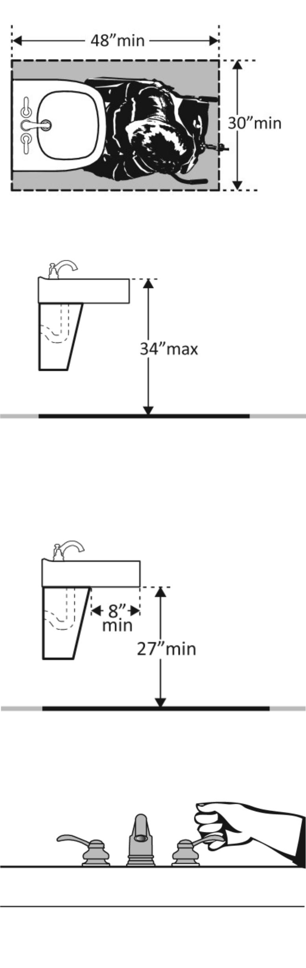

64

Chapter 3: Internal Service & Facilities

12. Sanitary Facilities

 | Y/N | Standard | Reference | Recommendation

 | Water Closets in Single-User Toilet Rooms and Compartments (Stalls)
12.23 |  | Is the facility commode? | □Yes
 |  |  | □No
12.24 |  | Is the centerline of the water closet no | □Yes
 |  | less than 16 inches and no greater than | □No
 |  | 18 inches from the side wall or
 |  | partition? | ______
12.25 | Is clearance provided around the water |  | □Yes
 | closet measuring at least 60 inches from |  | □Yes
 | the side wall and at least 56 inches from |  | □No
 | the rear wall?* |  | ______
12.26 | Is the height of the water closet no less |  | □Yes
 | than 17 inches and no greater than 19 |  | □No
 | inches above the floor measured to the |  | □No
 | top of the seat? |  | ______
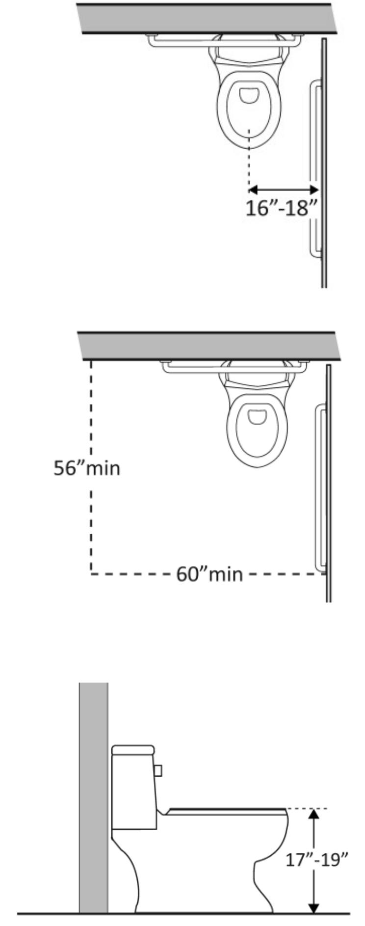

65

Chapter 3: Internal Service & Facilities

12. Sanitary Facilities
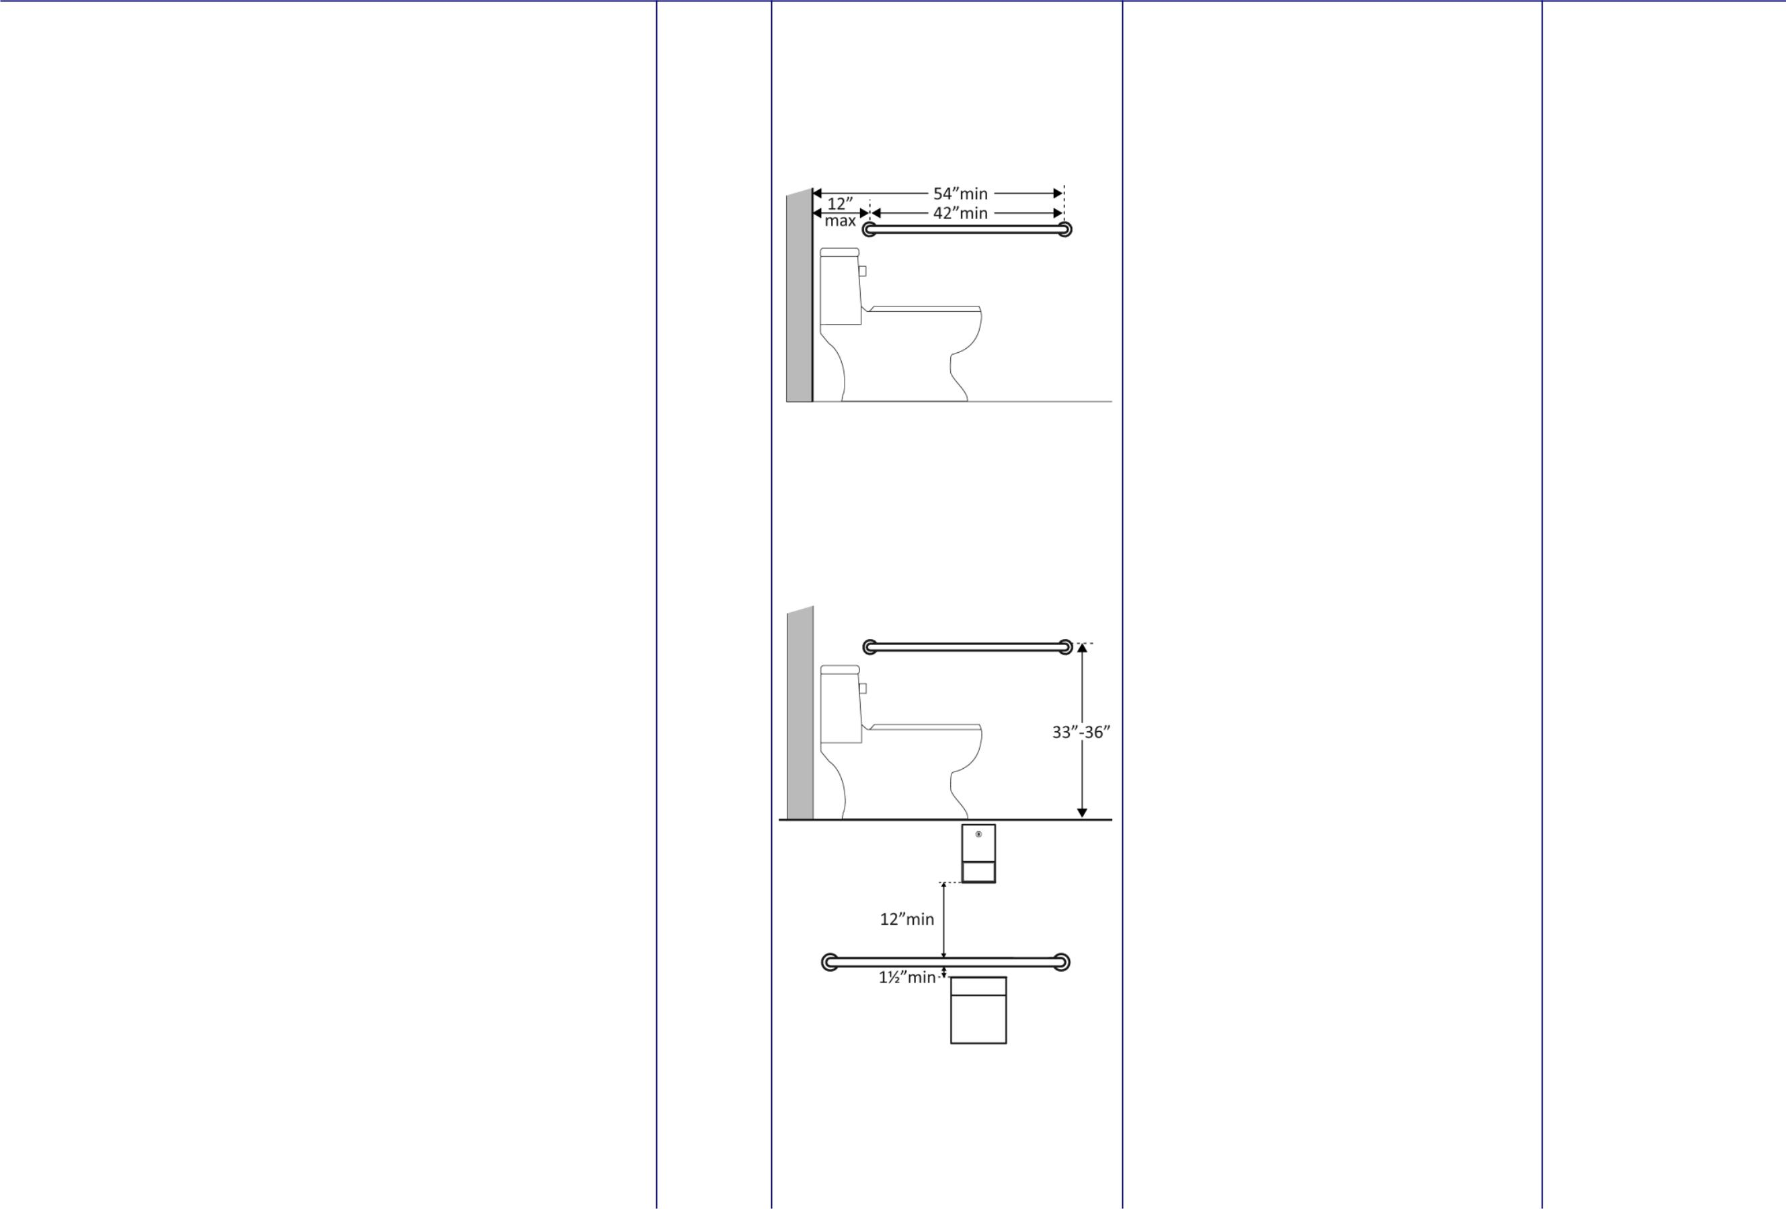

Y/N | Standard | Reference | Recommendation

12.27 | Is there a grab bar at least 42 inches | □Yes
 | long on the side wall? | □No
 |  | ____
 | Is it located no more than 12 inches | □Yes
 | from the rear wall? | □No
 |  | ____
 | Does it extend at least 54 inches from | □Yes
 | the rear wall? | □No
 |  | ____
 | Is it mounted no less than 33 inches | □Yes
 | and no greater than 36 inches above | □Yes
 | and no greater than 36 inches above | □No
 | the floor to the top of the gripping | □No
 | surface? | ____
 | Is there at least 12 inches clearance | □Yes
 | between the grab bar and protruding | □No
 | objects above? | ___
 | Is there at least 1½ inches clearance | □Yes
 | between the grab bar and projecting | □No
 | objects below? | ____
 | Is the space between the wall and the | □Yes
 | grab bar 1 ½ inches? | □No
 |  | ____

66

Chapter 3: Internal Service & Facilities

12. Sanitary Facilities

 |  | Y/N | Standard | Reference | Recommendation
12.28 | Is the grab bar at least 36 inches long on | □Yes
 | the rear wall? | □No
 |  | ____
 | Does it extend at least 12 inches from the | □Yes
 | centerline of the water closet on one side | □No
 | (side wall)? | ____
 | Does it extend at least 24 inches on the | □Yes
 | other (open) side? | □No
 |  | ____
 | Is it mounted no less than 33 inches and | □Yes
 | no greater than 36 inches above the floor | □No
 | to the top of the gripping surface? | □No
 |  | ____
 | Are there at least 12 inches clearance | □Yes
 | between the grab bar and protruding | □No
 | objects above? | □No
 | objects above? | ___
 | Are there at least 1½ inches clearance | □Yes
 | between the grab bar and projecting | □No
 | objects below? | □No
 | objects below? | ____
 | Is the space between the wall and the grab | □Yes
 | bar 1½ inches? | □No
 |  | ____
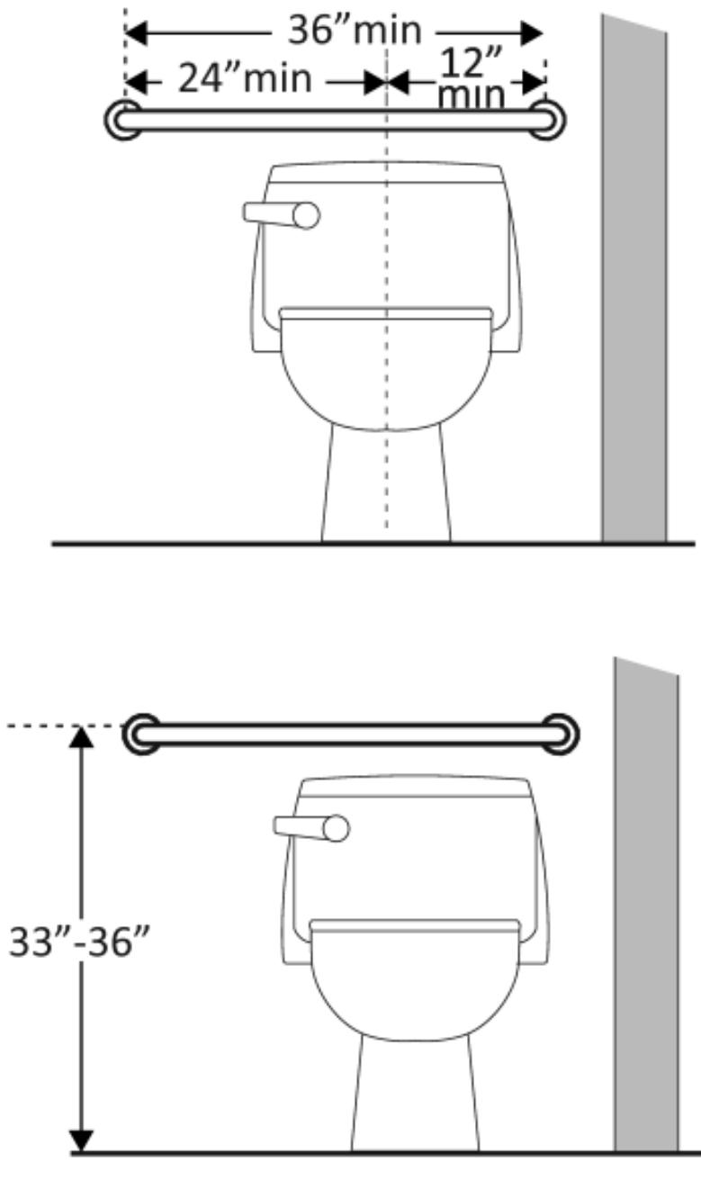
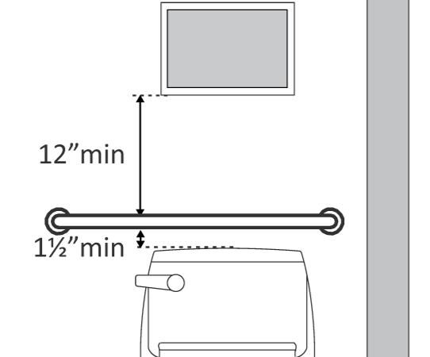

67

Chapter 3: Internal Service & Facilities

12. Sanitary Facilities

 |  | Y/N | Standard | Reference | Recommendation
12.29 | If the flush control is hand operated, is | □Yes
 | the operable part located no higher than | □No
 | 48 inches above the floor?
 |  | ______
12.30 | If the flush control is hand operated, can it | □Yes
 | be operated with one hand and without | □No
 | tight grasping, pinching, or twisting of the | □No
 | wrist?
 | Is the force required to activate the flush | □Yes
 | control no greater than 5 pounds? | □No
 |  | ______
12.31 | Is the height of the urinal not more than | □Yes
 | 30 inches? | □No
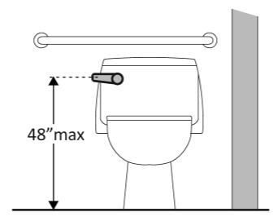
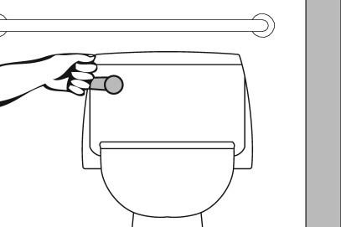

68

Chapter 3: Internal Service & Facilities

12. Sanitary Facilities

 | Y/N | Standard | Reference | Recommendation

 | Toilet Compartments (Stalls)
12.32 |  | Is the door self-closing? |  | □Yes
 |  |  |  | □No
12.33 | Is the lock operable with one hand and |  |  | □Yes
 | without tight grasping, pinching or |  |  | □No
 | twisting of the wrist? |  |  | □No
12.34 | If the door swings in, is the minimum |  |  | □Yes
 | required compartment area provided |  |  | □No
 | beyond the swing of the door (60 inches x |  |  | □No
 | 56 inches if water closet is wall hung or 59 |  |  | ______
 | inches if water closet is floor mounted)?
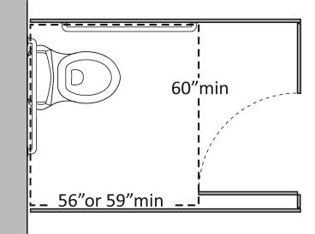
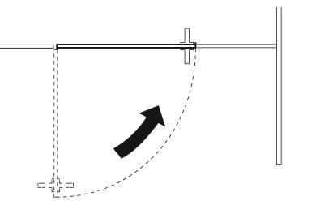
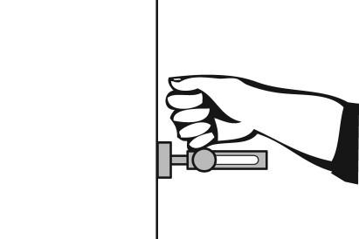

69

Chapter 3: Internal Service & Facilities

13. Security Services

 |  |  |  | Y/N | Standard | Reference | Recommendation
 | Alarm System
13.1 | If there are alarm systems, do they have |  |  | □Yes
 | both flashing lights and audible signals? |  |  | □No
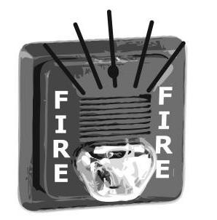

70

Chapter 3: Internal Service & Facilities

14. Evacuation Routes

 |  |  | Y/N | Standard | Reference | Recommendation
Fire Escape
14.1 Are emergency exits easily identifiable? |  |  | □Yes
 |  |  | □No

14.2 Are emergency exits easily accessible? | □Yes
 | □No

14.3 Is the lift an ‘evacuation lift’? | □Yes
 | □No

14.4 Is safety drill performed? | □Yes
 | □No

71
Chapter 4: Information & Communication

15. Information & Communication

 |  | Y/N | Standard | Reference | Recommendation
15.1 | Is there information detailing the | □Yes
 | accessible facilities in the building with | □No
 | photograph. | □No
15.2 | Are staff members trained in Sign | □Yes
 | Language interpretation. | □No
 | Or,
 | Are Sign language interpreters available in
 | call.
15.3 | Is adequate support available for persons | □Yes
 | form different cultures, learning | □No
 | disabilities, those not formally educated, | □No
 | in all above provision
15.4 | Is lighting adequate & without glare | □Yes
 |  | □No

72

